Country Statistics User Guide
Coverage, Methodology & FAQ

MarketLine Advantage

Table of Contents
1. Country Data 3
1.1. How to access 3
2. Overview Dashboard 5
3. Industry Dashboards 7
4. Sector Dashboard 8
5. Country Snapshot Dashboard 10
6. Data Download 11
7. Methodology and Frequently Asked Questions 12
7.1. Sourcing, quality and confidence 12
7.1.1. Where do you collect your data from? 12
7.1.2. How trustworthy is your data? 12
7.1.3. What kind of quality control measures do you implement? 12
7.1.4. How do you ensure consistency in the definitions when your data is from multiple sources? 12
7.1.5. How do you overcome gaps in source data? 12
7.1.6. How confident can you be in your data for obscure or less-developed markets? 12
7.2. Forecasting 13
7.2.1. How do you forecast your data? 13
7.2.2. How are your exchange rates forecast? 13
7.3. Update cycles 13
7.3.1. How often do you update your data? 13
7.3.2. How do you ensure you are aware of any revised data or new data releases? 13
7.4. Coverage 13
7.4.1. How do you choose your countries? 13
7.4.2. How do you choose your indicators? 14
7.5. Data Downloads and Extracts 14
7.5.1. How do I download data from the tool? 14
7.5.2. Can I extract charts and graphics from the tool? 14
7.5.3. What is the difference between the various download options? 15
7.5.4. What is the best download option for MS Excel? 16
7.5.5. Why are the ‘Data’ and ‘Crosstab’ options greyed out and unavailable? 16
7.6. General data questions 17
7.6.1. Why are the values in your database different to other sources? 17
8. About MarketLine 18
8.1. MarketLine Advantage 18
8.1.1. Company Information 18
8.1.2. Sector Information 19
8.1.3. Country and City Information 19
8.1.4. News and Financial Deals 20

Country Data

How to access
MarketLine’s Country Statistics Data can be accessed in the Databases menu in the MarketLine Advantage navigation bar or through the Browse by Databases link on the MarketLine Advantage homepage:

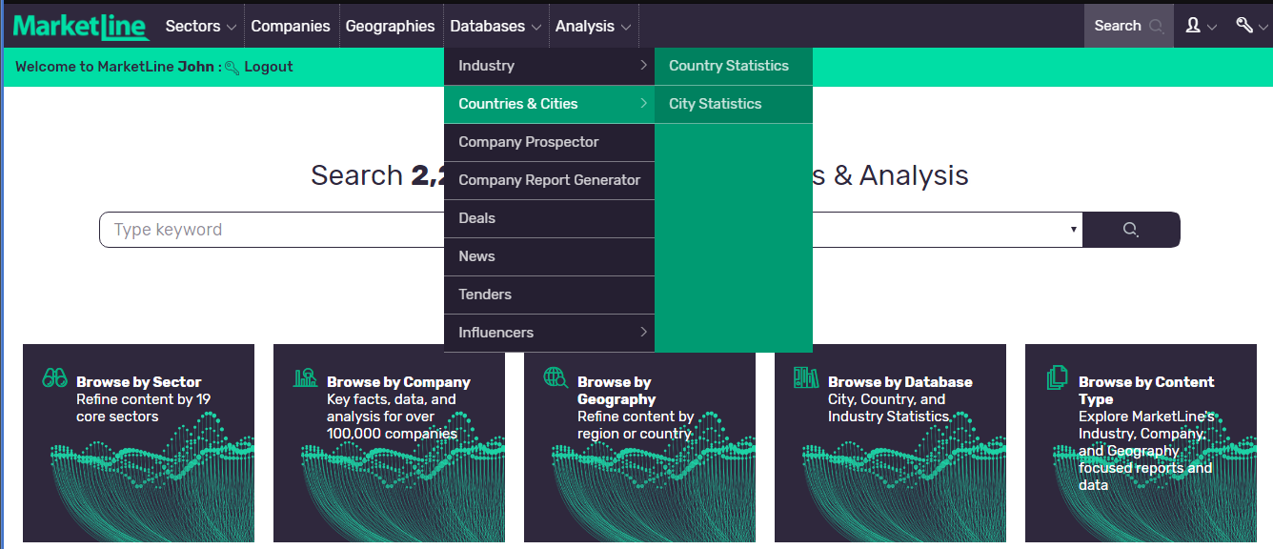

Once you’re on the Databases section click “Country Statistics” to be automatically directed to the Country Data ‘Home’ page.

Here, you can find some information regarding our country level macroeconomic indicators and an interactive map showing the extent of our coverage.
By clicking on a country of your preference on the map you can quickly view a snapshot; this will be discussed in further detail in the ‘Country Snapshot’ section. Additionally, you will find tabs along the top of your screen which will direct you to each of our global overview and industry dashboards.
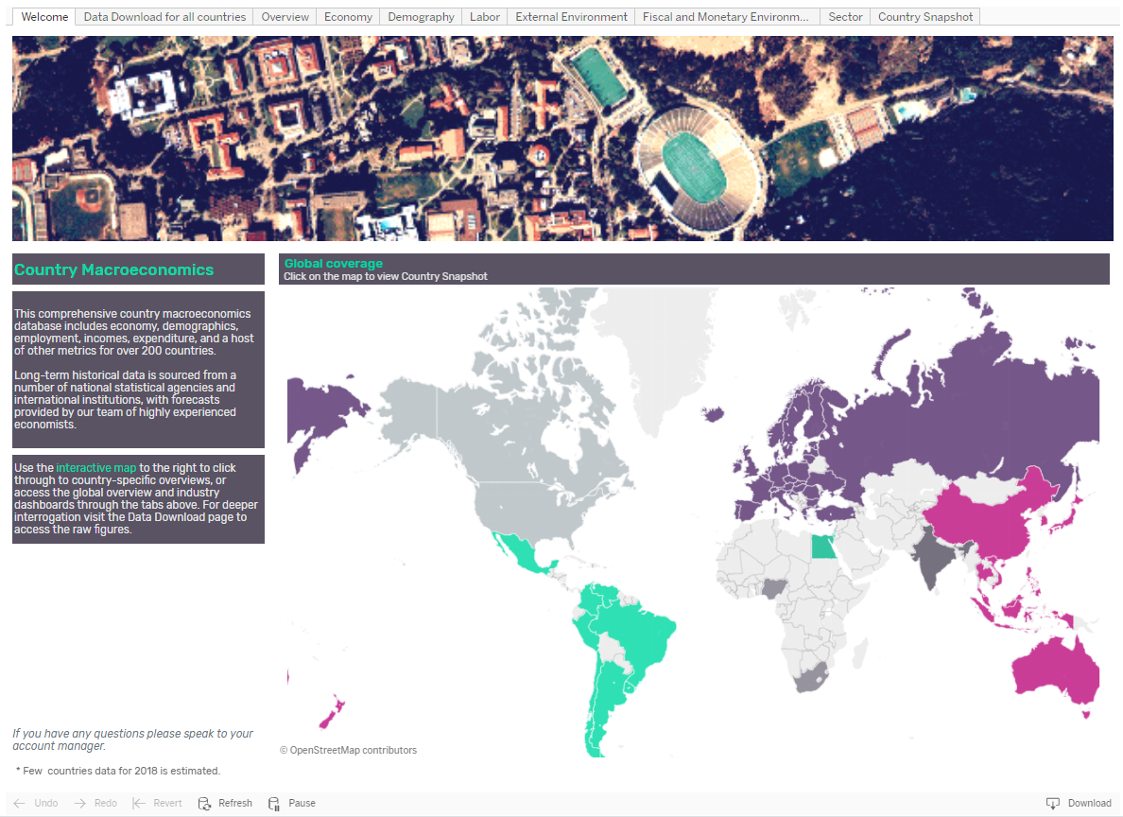

Overview Dashboard
Along the top of each page runs a navigational bar. Click on each tab to access that specific dashboard. The first is the ‘Overview’ dashboard where you will find an insight into the top level data covered. Once on the ‘Overview’ page you will find top level indicators visualized geographically, with a supporting data table.
- Indicator, year, and geography filters can be found in the left hand side bar; updating these will amend the data shown in the charts within that dashboard. Any legends featured throughout the dashboard are also located here
- Here you can find data on a variety of indicators for your chosen year; these indicators provide broader information than the other dashboards, which give a more niche, thematic values
- Values are shown geographically on a map, and ranked alphabetically in the right hand side table. Below the map, regional averages are provided over time, based on your indicator selection
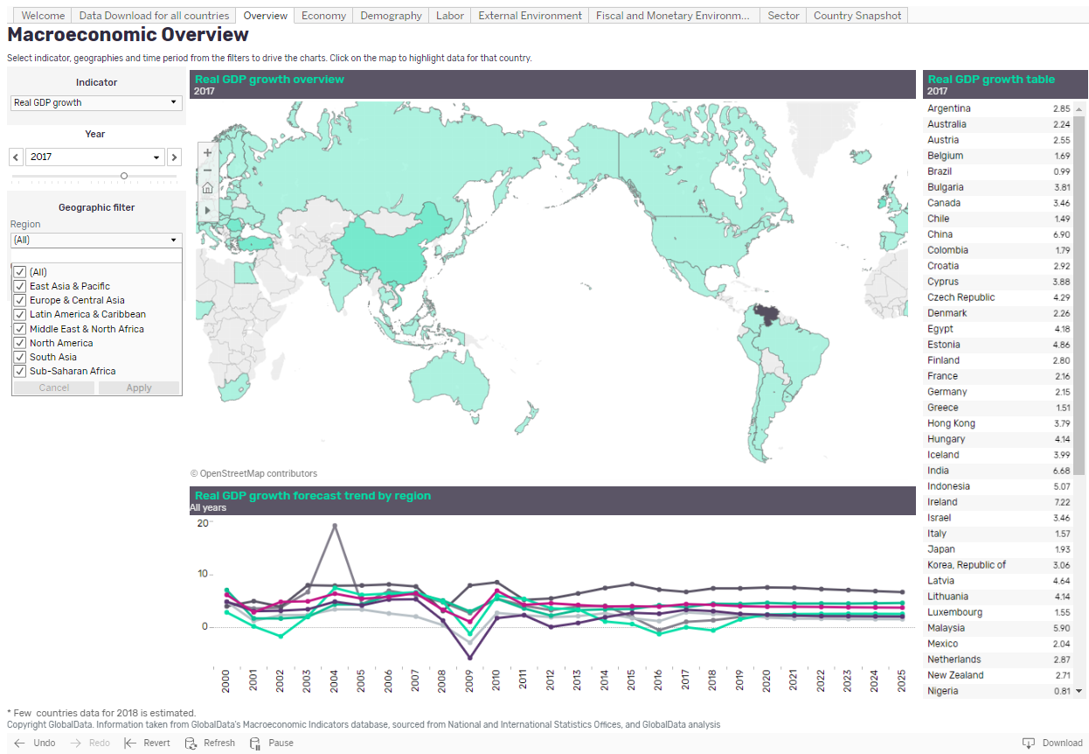

For example:
- Update the ‘Region’ filter to ‘North America’ by clicking on the ‘Region’ dropdown, deselecting ‘All’, reselecting ‘North America’ and clicking ‘Apply’. The charts and tables will update accordingly
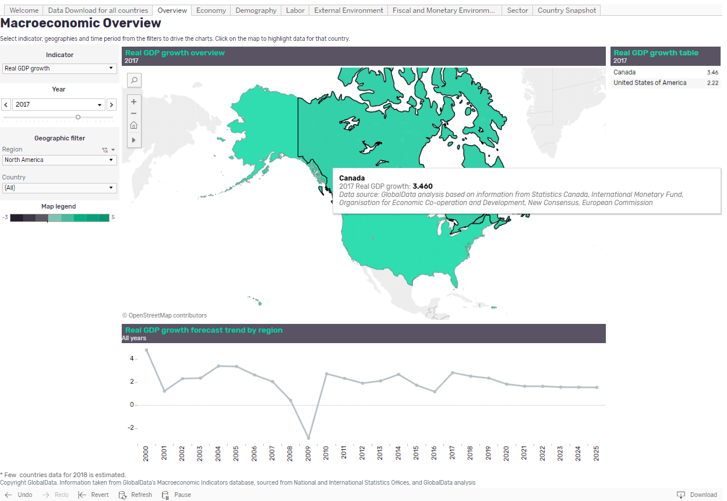
- If you hover over any data point with the cursor, this will show more information for that particular data value
- Selecting a country on the map, country in the table or data point on the forecast trend line will allow you to isolate or delete a data point by selecting ‘Keep only’ or ‘Exclude’ respectively
- You can download these values by activating the chart or table by clicking on it, selecting the ‘Download’ button at the bottom right corner of the screen, and choosing your desired format (eg Crosstab (recommended), PDF, Image)
- By hovering your cursor on the left hand side of the map this will make a number of features visible, including a search function in order to look up the region or country of your preference
- To undo your previous selection, click ‘Undo’ and click ‘Revert’ to undo all of your selections

Topic Dashboards
The layout for the ‘Economy’, ‘Demography’, ‘Labor’, ‘External Environment’ and ‘Fiscal and Monetary Environment’ dashboards are all similar. We shall use the ‘Economy’ dashboard as an example.

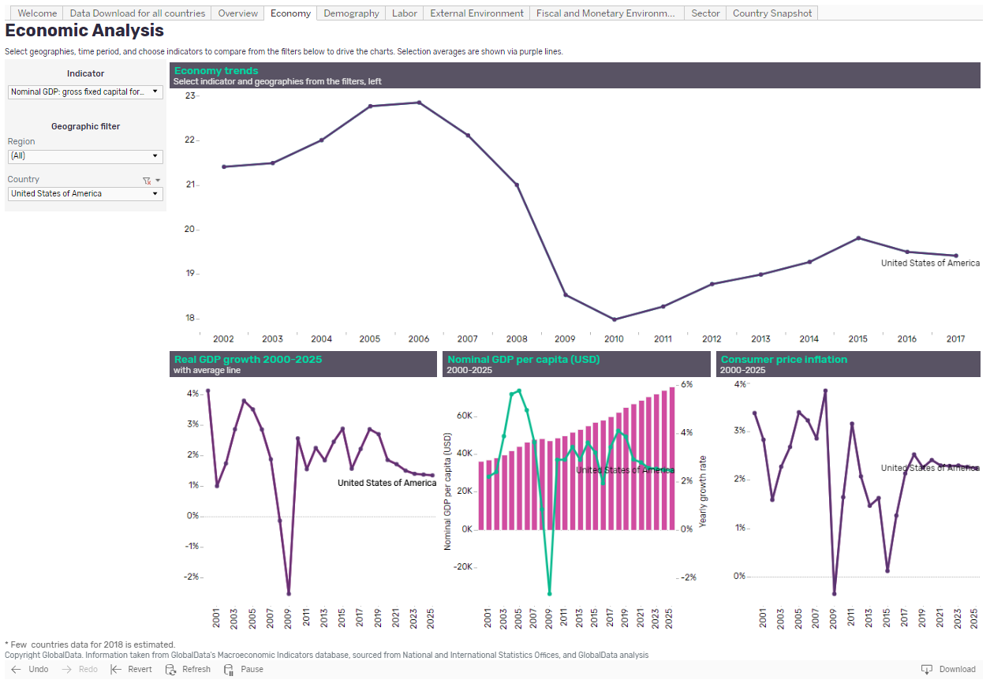

- Similar to the ‘Overview’ tab, you will find a number of filters down the left hand side bar on your page, these once again include ‘Indicator’, ‘Region’, and ‘Country’
- As before, using the filters you can adjust the indicators and geographies shown to your preference
- The top line chart is driven by your selections, while the bottom row of charts are fixed, with only geography being updateable here
- For your chosen geographic filters you will find a ‘Selection average’ as a purple trend line on many charts. Where this is present it is indicated in the chart title

Sector Dashboard
The ‘Sector’ dashboard allows you to analyze and compare data across regions and countries for different sectors of the economy, ranging from travel and tourism to financial services.

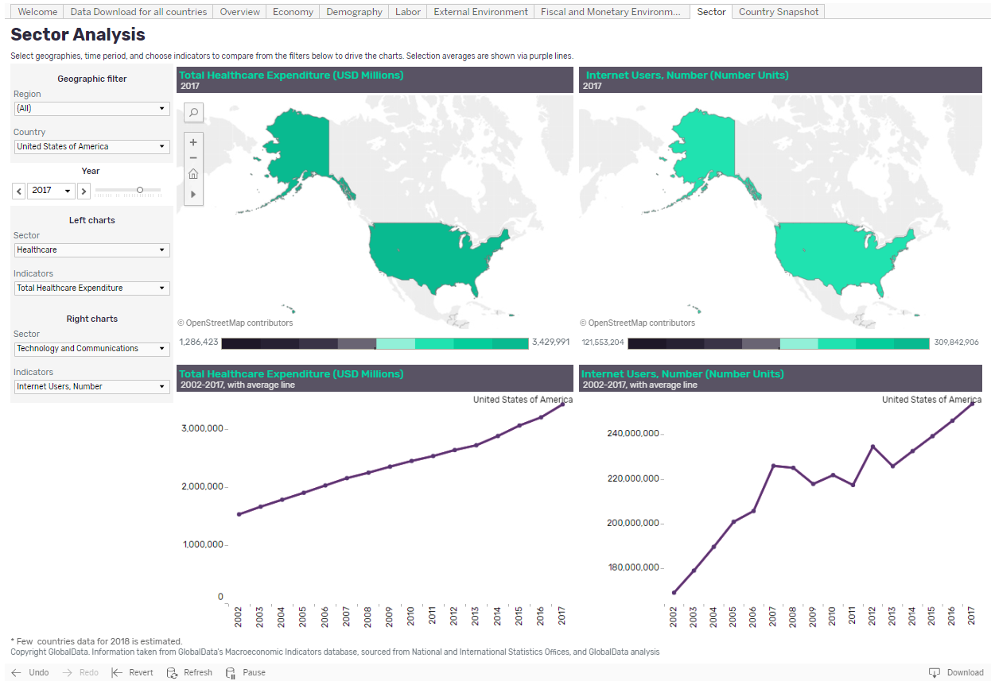

- You will find a number of filters down the left hand side bar on your page, beyond the standard geographic and year filters, you can choose which indicators to show in which chart set (eg left or right column)
- The charts are paired, with a map and time-series line chart being updated based on your indicator selections
For example, compare the number of registered passenger cars with the level of CO2 emissions over time, focusing on 2010 in China and Russia,

- Firstly, Using the ‘Country’ filter select ‘China’ and ‘Russian Federation’, click ‘Apply’
- Update the ‘Year’ filter to show 2010
- In the ‘Left charts’ pane select ‘Automotives’ from the ‘Sector’ filter, then pick ‘Passenger cars, registered vehicles’ from the ‘Indicators’ dropdown. The list of available indicators will update based on your ‘Sector’ selection
- This will update the entire left hand side group of charts (map and time series)
- Similarly, within the ‘Right charts’ pane select ‘Environment’ from the ‘Sector’ filter, then pick ‘CO2 emissions from the ‘Indicators’ dropdown
- The right hand side group of charts will now display these values
- As with other charts, hover over individual data points for more information and activate the chart to ‘Download’ data for further analysis

Country Snapshot Dashboard
When you select a country on the map in the ‘Welcome’ page it will direct you to the respective ‘Country Snapshot’. The dashboard can also be accessed via the tab along the top of each page.
The ‘Country Snapshot’ provides a broad insight into a country of your preference. Fixed charts (real GDP growth, nominal GDP per capita, CPI, unemployment rate, and budget surplus/deficit) show trends from 2000-2025 for your chosen market, plus a map. Use the map to change your country selection or navigate back to the ‘Welcome’ page.
For example, the below is shown when the United States has been selected.
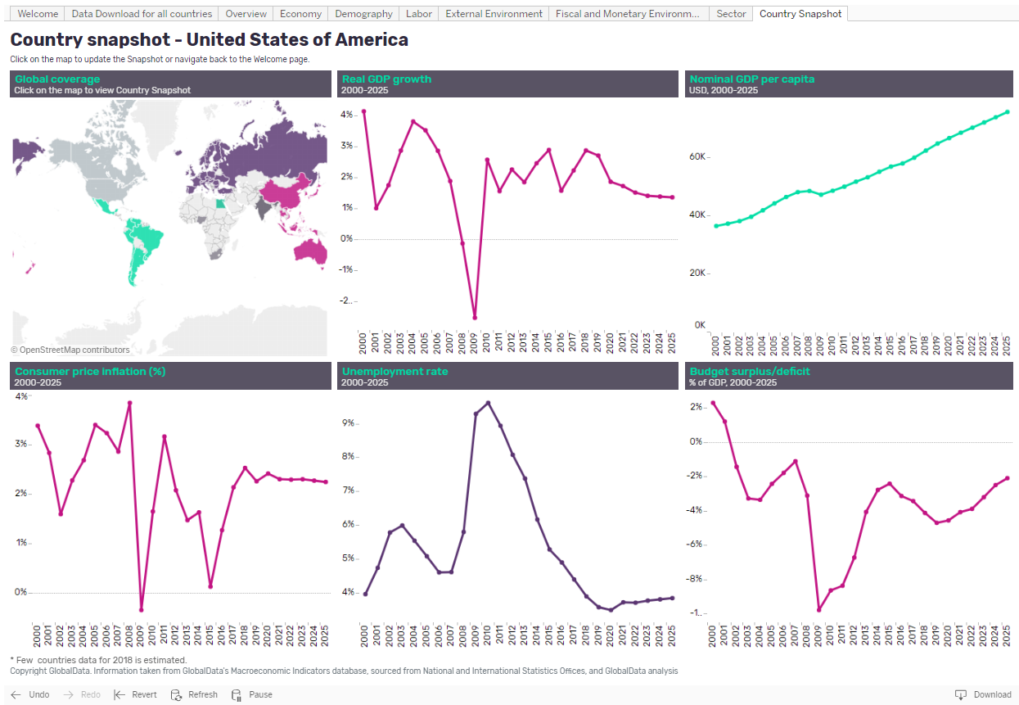
- To change the country shown, select the country you want to see on the map and click ‘Select country’. The page will update accordingly
- If you want to return to the ‘Welcome’ page at this point, select ‘Go back to Welcome page’

Data Download
The ‘Data Download for all countries’ page provides the same data available on the other dashboards, but here all indicators are available to select at once for multiple years and geographies.

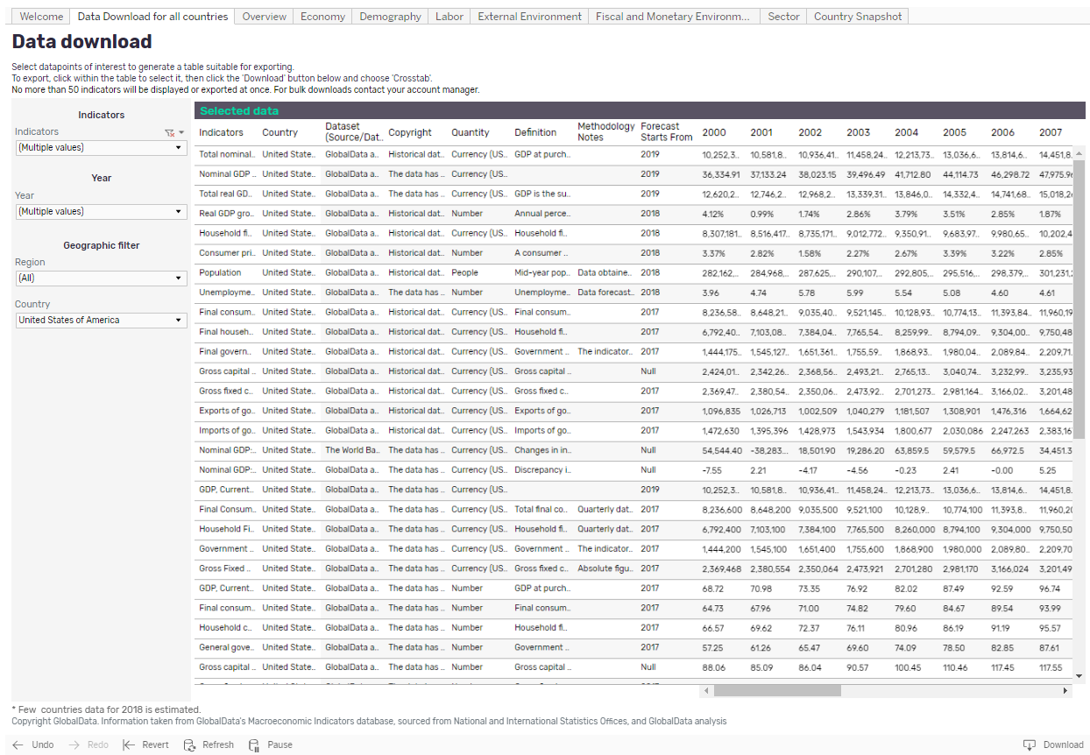

- On the left hand side bar you can explore different indicators, geographies and time periods
- Update the selection to your preferences and click ‘Apply’; the data will appear in a pivot table format as a time series
- To download the data, click within the table to activate it and navigate to the ‘Download’ button at the bottom right corner of the screen and click it. From here choose your desired download format (Crosstab is recommended) and follow the on-screen instructions to access the file

Methodology and Frequently Asked Questions

Sourcing, quality and confidence

Where do you collect your data from?
The country statistics database is maintained by a specialized team of analysts trained to use sophisticated econometric modeling techniques and propriety models. Data is sourced from national and international bodies such as National Statistics Organizations, Central Banks, trade associations, the World Bank, IMF, UN, and OECD.

How trustworthy is your data?
Our credibility is driven by our data sources and our modelling methodology. Official statistics offices can typically be trusted as they are a either a governmental department or highly regarded independent organization which may report to the national government, or on their behalf. If we have low confidence in a source data point, regardless of the general credibility of the source, we carry out a secondary checking procedure to verify or discount the data. We maintain a level of transparency on such issues by providing information on our sources.

What kind of quality control measures do you implement?
To ensure the highest quality data possible, quality checks are implemented at every stage of the end-to-end process. We ensure the validity of our data with numerous automated tests, as well as manual checking of data points and overall trends. Additionally, we regularly re-evaluate our modelling logic to ensure we are continually enhancing our understanding of how intelligence on countries should be represented.

How do you ensure consistency in the definitions when your data is from multiple sources?
A consistent and robust dataset is of paramount importance. All source definitions are checked thoroughly before the data is extracted to ensure consistency and an estimation approach is implemented if absolutely necessary.

How do you overcome gaps in source data?
We use a variety of techniques depending on the severity of data availability however, in simple cases, we are able to impute missing values by using linear trend methods, which produces the lowest standard error.

How confident can you be in your data for obscure or less-developed markets?
Where we are unsure of the reliability of a data source we ensure figures are aligned with secondary materials. Beyond this, our hierarchical modelling approach enables us to credibly provide estimations for hard-to-research markets.

Forecasting

How do you forecast your data?

For all key indicators ( GDP, private final consumption expenditure, inflation, exchange rates, unemployment rate, and population) country level time series data updated in models after passing through all the quality checks in terms of data consistency and flow. In this stage, each data series is compared with best possible source available for access and accordingly final data is considered in model to reflect latest update. National and global high frequency data (WB Monthly publication) series considered to estimate YTD figures for current year and accordingly full year numbers are derived. For future years, data has been forecasted using consensus rates derived from multiple sources such as IMF, Country specific central banks and ministry projections, Consensus economics (87 countries), African development bank, Asian development bank, European commission, OECD, Eastern Caribbean central bank, Inter-American development bank and World Bank.

For other indicators, advanced statistical and econometric techniques such as linear regression, multiple regressions, time series autoregressive method, exponential smoothing techniques and time series decomposition methods are applied based on applicability.

How are your exchange rates forecast?
The latest year is estimated by taking into account year-to-date data; while the forecast is derived using International Monetary Fund implied exchange rates till 2023. For remaining years 2024-25, data has been forecasted using linear model.

Update cycles

How often do you update your data?
Our team of Researchers and Analysts follow an annual update cycle for most of the indicators except key indicators (GDP, private final consumption expenditure, inflation, exchange rates, unemployment rate, and population) which are revised quarterly based in YTD data available from country specific sources and World Bank monthly data publication.

How do you ensure you are aware of any revised data or new data releases?
Our Analysts keep a record of source data cycles to ensure that when a source’s data is revised our data set is also updated. Most of our updates are planned as per the source release data updates.

Coverage

How do you choose your countries?
Country Statistics covers all the countries in the world, however not all indicators are available for each country. We have categorized countries into top 25 and top 65 categories on the basis of size of economy, usage statistics, client demand, and data availability. The countries categorized under top 25 and top 65 are the best covered geographies in terms of data availability and forecasts.

How do you choose your indicators?
To meet our goal of creating the most comprehensive countries database in the market we have selected our indicators based on reliability and depth of the data available, usefulness in making business decisions, and client feedback.

Data Downloads and Extracts

How do I download data from the tool?
The ‘Data Download for all countries’ dashboard provides the same data available on the other dashboards, but on this page you are able to select multiple indicators for multiple years. Update the indicator selection as per your preferences using the filters in the left hand side bar, and then download as an Excel file by selecting ‘Crosstab’ option from download icon provided beneath the page in right hand side. Also, there are other format options such as Image, Data (text file) and PDF available as part of download options on tool. To ensure a swifter user experience, downloads are limited to 50 indicators at a time.

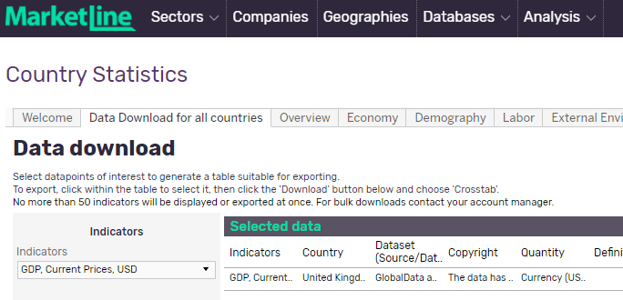

From here select the Indicators, Years, and Countries of interest from the filters on the left of the screen (make sure you select apply at the bottom of each dropdown filter) then use the Download option at the bottom right of the screen to download in the desired format (Crosstab is best for data).
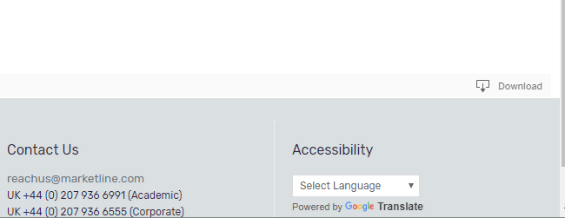

Can I extract charts and graphics from the tool?
Yes, any dashboard (tab) or view can be downloaded from the database using the download option at the bottom right of the page.
Click ‘Download’ select either image or PDF as your preferred file format:
- Image will open a dialog box asking you to confirm the download in PNG format
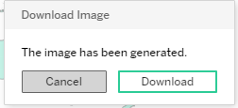
- The downloaded image will be of the whole dashboard so you may need to crop the image if you want a single chart or section
- PDF will open a dialog with further options on Layout, Paper Size, Scaling and Content
  - Layout: Select the orientation of the PDF document; portrait or landscape
  - Paper Size: Select the page size for the PDF document, various standard paper size formats are available
  - Scaling: Select how the image is scaled to fit the PDF document, default is Automatic and we recommend using this option.
  - Content: You can select which content is pulled into the PDF when generated.
    - ‘This Dashboard’ will include only the current screen/dashboard.
    - ‘Sheets in Dashboard’ will allow you to extract individual charts from the current screen/dashboard. Each chart will have a ‘sheet’ associated with it.
    - ‘Sheets in Workbook’ allows you to select any of the dashboards in the database and extract the current view (with the filters currently selected) to the PDF.
- Once you are happy with these options select ‘Generate’ and the PDF will be created
- Once ready a further dialog bow will inform you the PDF has been generated click the ‘Download’ button to view the PDF
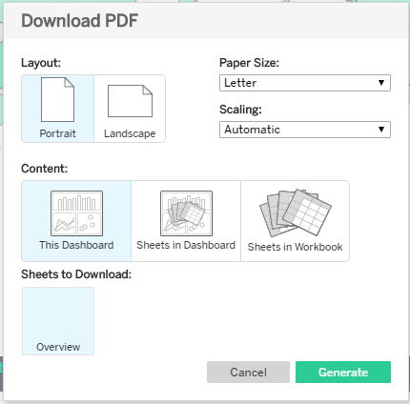

What is the difference between the various download options?
There are four download formats available from the country statistics database:
- Image: Downloads an image of the currently view in to a file using the Portable Network Graphic (PNG) format.
- Data: Opens a new window showing the data in rows in HTML format, this can then be exported as a Comma-Separated Values (CSV) file which can be opened in a wide range of text readers and spreadsheet packages (such as Excel).
- Crosstab: Downloads the data in table format (using multiple columns to display the data) as a Comma-Separated Values (CSV) file which can be opened in a wide range of text readers and spreadsheet packages (such as Excel).
- PDF: Download either the current view, selected charts from the current view or selected dashboards from the whole database into a file using Portable Document Format (PDF) format.
- Tableau Workbook: Not available.
Both the Data and Crosstab options are great for use in spreadsheets however the data is displayed slightly differently in both. With the Data option values are organised into a single column with multiple year’s being included in multiple rows. With the Crosstab option values are shown across multiple columns so a single indicator is shown on each row and years spread out over multiple columns. The following image shows the same data downloaded in each format.

Data (Data is organized in rows)
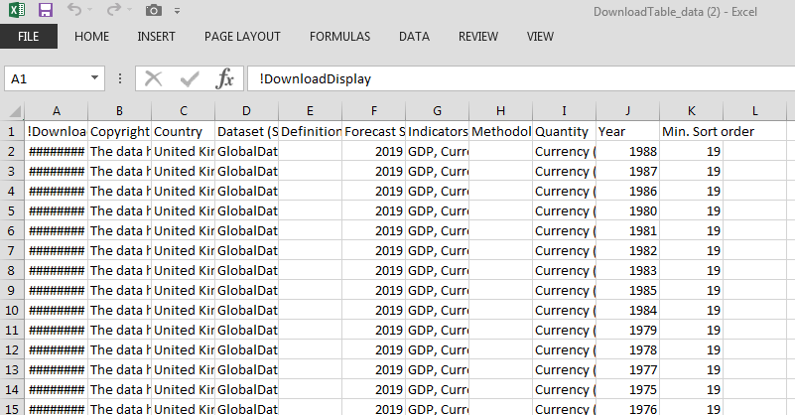

Crosstab (Data is organized in columns)
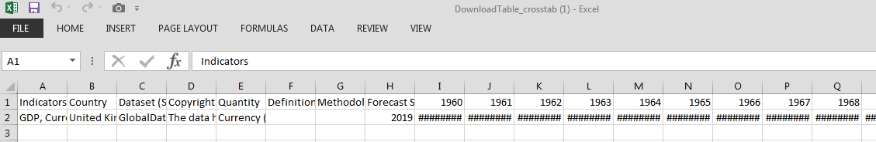

What is the best download option for MS Excel?
Use either the ‘Data’ or ‘Crosstab’ options. In Crosstab format the data is set out in tabular style so is the most common option for excel spreadsheets.

Why are the ‘Data’ and ‘Crosstab’ options greyed out and unavailable?
Before downloading the data in either of these formats you’ll need to make sure the table or chart you want to download the data from is active; do this by left clicking on the section you are interested in before selecting ‘Download’.

General data questions

Why are the values in your database different to other sources?
The data points that our competitors provide may vary depending on a variety of factors, for instance, there may be a difference in the source of data or definition of the indicator or update frequency. Our approach is focused on providing the most complete database on countries within the market, which may not necessarily be the same motivation of our competitors, as we strongly believe there is a need to enable comparative analysis across countries (in similar fashion to how cities are analyzed in our City Data tool).

If you have any queries or need further information please contact your account manager.

Country Coverage

About MarketLine

MarketLine Advantage
First stop data and insights for Sectors, Companies, and Countries & Cities globally.

MarketLine Advantage is a holistic business information resource which meets a multitude of research needs across your organisation. Whether you sit within Advertising, Strategy, Finance, Marketing, Business Development, or Research, MarketLine delivers the data you need for strategic planning, competitive analysis, or forecasting in an instant.

The user friendly MarketLine Advantage platform is structured around three key pillars – Sectors, Companies, and Geographies. Whether you want to zoom in and learn more about a specific company, or step back to look at an industry and its geographic context, MarketLine can help. We cover business information from the ground up, so you can connect the dots and make better business decisions.

Company Information
Company Profiles provide company and competitor information, commentary and analysis, substantiated by facts and market trends for the top 100,000 global companies across all vertical industries. SWOT Analysis is now available for the top 12,000 companies.

Company Case Studies provide an in-depth analysis of successful and unsuccessful company strategies.

Company Prospector enables you to screen companies and build lists of potential business partners, clients, and investment targets in industries and countries of interest.
Identify advisory & investment firms operating in specific industries, and gain insight into the investment and inorganic strategy of companies, with MarketLine’s Investment & Advisory Prospector.

Company Report Generator can be used to build fresh custom company reports featuring analytical text and charts which draw on MarketLine's company datasets. Example sections include company overview, history, SWOT analysis, M&A, partnerships and agreements, news and product information.

Top Companies Chartbooks (MarketLine Plus) benchmark leading companies through a variety of financial metrics. This series provides a breakdown of the subject market’s segmentation, and company-specific overviews for each of the leading companies.

This information can be used to:
- Track competitors business strategy and prospects
- Benchmark Company performance
- Identify business leads and channels
- Support sales activities by understanding customers’ businesses better
- Evaluate prospective partners and suppliers
- Develop sales pitches, presentations and studies
- Assess competitor strategies to ascertain what has worked, and why
- Understand the rationale behind significant company developments and innovations

Sector Information
Industry Profiles give a clear picture of the key dynamics in each sector, including the leading companies operating within each sector, new entrants, the key suppliers and levels of competitor rivalry. Concise and accurate, Industry reports include practical application of Porter’s Five Forces analysis.

Industry Datafiles (MarketLine Plus) are interactive Excel-based workbooks that present MarketLine industry data an easy to work with spreadsheet format. Each Datafile provides multiple views to easily comprehend or analyse data for single markets or quickly compare data across countries, along with the underlying raw data. Each Datafile consists of industry data for 50 countries and 9 regions including Asia-Pacific, North and South America, Europe and the Middle East.

MarketLine’s Industry Statistics database (MarketLine Plus) consolidates all the data from Industry Datafiles into a single web based interface, enabling quick and easy comparative analysis of market values, volumes, and forecasts for over 120 industry sectors and 50 countries. Industry Statistics is available under the Databases section of MarketLine Advantage.

Industry Value Chain reports(MarketLine Plus) reveal the business activities which comprise the Industry value chain for 100 major global sectors. All key stages are highlighted, along with examples of companies active, and assessments of the burning issues for every stage of the value chain.

Industry Case Studies provide in-depth analysis of wider ranging issues affecting the subject industry.

Theme Reports are a new report series looking into topics or megatrends impacting multiple industries, sectors, and countries.

Use MarketLine Industry content to:
- Save time carrying out research by identifying the size, growth, major segments, and leading players in global industries
- Use the Five Forces analysis to determine the competitive intensity and therefore attractiveness of each industry
- Add weight to presentations and pitches by understanding the future growth prospects of each subject industry with five year forecasts
- Identify key datapoints and trends using interactive charts and tables
- Compare industry data across sectors and geographies
- Easy download and extraction/manipulation of raw data for use in own reports
- Quickly and easily identify the key stages and sub-stages of each global industry value chain
- Analyse the activities undertaken at each stage of the value chain
- See examples of companies active at each stage
- Examine trends and burning issues impacting the each sector of the value chain
- Identify instances of vertical integration
- Pinpoint high growth markets or potential future market hotspots
- Understand the rationale behind significant industry developments and innovations

Country and City Information
Country Profiles provide an in-depth analysis of the world’s top 110 economies. Analysis is presented in terms of the political, economic, social, technological, legal and environmental (PEST/PESTLE) structure of the subject country.

MarketLine’s Country Statistics database enables users to conduct quick and easy comparative analysis of macroeconomic and industry drivers for over 200 countries. Features include comprehensive data and forecasts including detailed coverage of consumer demographics, incomes, and expenditures. Country Statistics is ideal for professionals requiring a comprehensive view of the global economy or at a much higher level, a comparative analysis view of countries or indicators.

City Profiles include a comprehensive overview of the subject city, political, economic, social, technological (PEST) analysis, along with analysis of key industries including technology, tourism and hospitality, construction and retail.

City Statistics features comprehensive data and forecasts of key socio and macroeconomic indicators for more than 3000 cities, spread across Asia-Pacific, Europe, Middle East & Africa, North America, and South &Central America Coverage is complemented by financial market indicators used in support of macroeconomic analysis, including commodity prices and indices, interest and exchange rates, and more.

Country Comparison Chartbooks (MarketLine Plus) provide in-depth analysis of Key Indicators within specific regions. They also look at High Income Economies, Middle Income Economies and Low Income Economies:

City Statistics Chartbooks (MarketLine plus) provide an overview analysis and comparisons of leading cities in terms of economics, demographics, employment, households, and education.

Country Outlook and Global Risk Reports, based on MarketLine’s Country Risk Index (MLCRI), assess current trends and risks facing all major global economies.
Use Country and City content to:
- Plan business investment or market entry in a particular country
- Gain a comprehensive knowledge of future economic and demographic trends and understand the performance of various sectors within countries and cities
- Analyse and understand the business environment in countries and cities to align your investment and expansion strategies.
- Help choose a suitable country or city to invest or expand according to your business structure.
- Explore new opportunities in the hospitality, tourism, construction, real estate and retail sectors.
- Get a detailed local view of the global economy and comparative analysis of cities or indicators

News and Financial Deals
MarketLine’s News, Financial Deals, Comment, and Analyst Insights complement the Industry, Company and Geography pillars perfectly.

Over 70,000 MarketLine authored News articles are added to site annually, along with over 200,000 company press releases. These articles help clients to track the latest developments in the industry, understand key trends and growth opportunities in different regions, and analyse the competitive landscape and shape company strategy.

MarketLine’s Financial Deals database is a record of global information on mergers and acquisitions (M&A); private equity, venture finance, and private placement transactions; IPOs; and partnerships across various industries. Over 56,000 Financial Deals are tracked annually. The database provides a complete resource for deal information offering the user detailed reports on deals, along with relevant data of the companies and advisors involved in such transactions.
Analyst Insights provide succinct analysis of events and actions across all global industries.

Analyst Comment and Analyst Insights provide opinion from MarketLine Analysts on current business issues and trends.

MarketLine’s News, Financial Deals, and Analyst Comment / Insights can be used to:
- Monitor competitor activity
- Identify investment opportunities and anticipate competitive moves
- Identify actionable business development opportunities
- Contextualize deals against company strategy and industry trends
- Track lists of active lenders
- Monitor market trends related to consolidation
- Track acquisition activity to identify exit targets
- Track divestment activity to identify acquisition targets
- Track investment history of portfolio companies to identify follow-on investment opportunities and understand target/focus markets
- Track deals to pitch, in order to build bidder, target, and seller lists
- Track global mergers and acquisitions (M&A), private equity deals, venture finance deals, private placements, IPOs, and partnerships

