City Statistics User Guide
Coverage, Definitions, Methodology & FAQ
Published: March 2019

MarketLine Advantage

Table of Contents
1. City Data 1
1.1. How to access 1
2. Overview Dashboard 3
3. Economic, Demographic, and Household Dashboards 5
3.1. Economic dashboard 5
3.2. Demographic dashboard 5
3.3. Household dashboard 5
3.4. Labor dashboard 5
4. INSIGHT FRAMEWORK 6
5. Latest data page 7
6. Data Download page 8
7. Definitions 9
7.1. Indicator definitions 9
7.2. Economy 9
7.3. Demographics 10
7.4. Employment 10
7.5. Households 11
7.6. Geographical definitions 11
8. Methodology and Frequently Asked Questions 13
8.1. Sourcing, quality and confidence 13
8.1.1. Where do you collect your data from? 13
8.1.2. How trustworthy is your data? 13
8.1.3. What kind of quality control measures do you implement? 13
8.1.4. How do you ensure consistency in the definitions when your data is from multiple sources? 13
8.1.5. How do you overcome gaps in source data? 13
8.1.6. How confident can you be in your data for obscure or less-developed markets? 13
8.2. Forecasting 14
8.2.1. How do you forecast your data? 14
8.2.2. How are your exchange rates forecast? 14
8.3. Update cycles 14
8.3.1. How often do you update your data? 14
8.3.2. How do you ensure you are aware of any revised data or new data releases? 14
8.4. Coverage 14
8.4.1. How do you choose your cities? 14
8.4.2. How do you choose your indicators? 15
8.4.3. Why do the area definitions of some cities differ? 15
8.4.4. Why do you not provide data on populations with “No Education”? 15
8.4.5. Why do you estimate GVA structure as opposed to GDP? 15
8.5. General data questions 15
8.5.1. Why are the values in your database different to other sources? 15
9. Appendix 16
9.1. Complete indicator list 16
9.1.1. Economy 16
9.1.2. Demographic 17
9.1.3. Employment 21
9.1.4. Households 21
9.2. Complete geography list 22
9.2.1. EAST ASIA & PACIFIC 22
9.2.2. EUROPE & CENTRAL ASIA 26
9.2.3. LATIN AMERICA & CARIBBEAN 30
9.2.4. MIDDLE EAST & NORTH AFRICA 33
9.2.5. NORTH AMERICA 34
9.2.6. SOUTH ASIA 37
9.2.7. SUB-SAHARAN AFRICA 39
9.3. MarketLine Advantage 41
9.3.1. Company Information 41
9.3.2. Sector Information 42
9.3.3. Country and City Information 42
9.3.4. News and Financial Deals 43

City Data

How to access
City Data can be accessed in the Databases menu in the MarketLine Advantage navigation bar or through the Browse by Databases link on the MarketLine Advantage homepage:

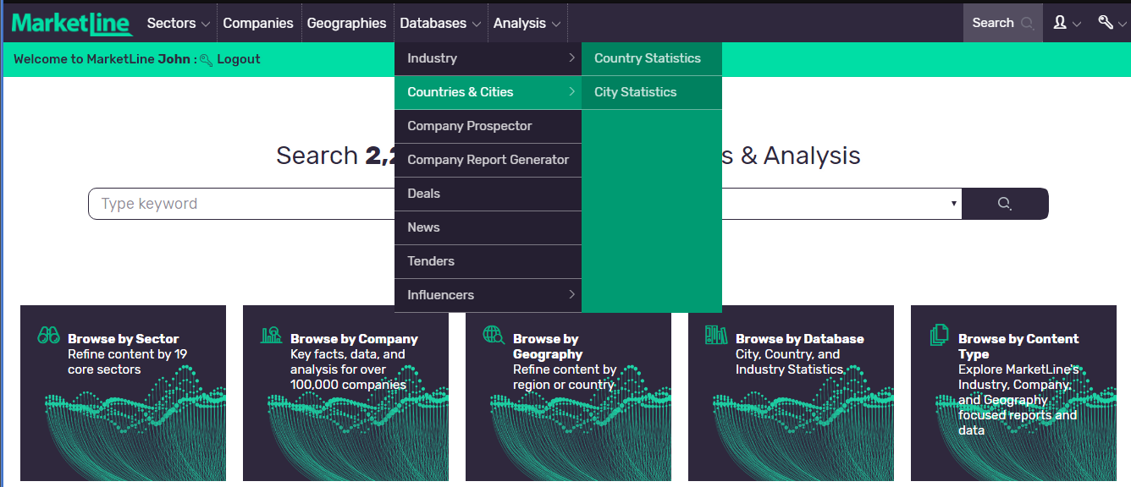

Once you’re on the Databases section click “City Statistics” to be automatically directed to the City Data ‘Home’ page.
Here, you will find a map showing our global coverage, links to each of our dashboards where you can access different indicators according to each theme, as well as our featured Insight Framework of the month. 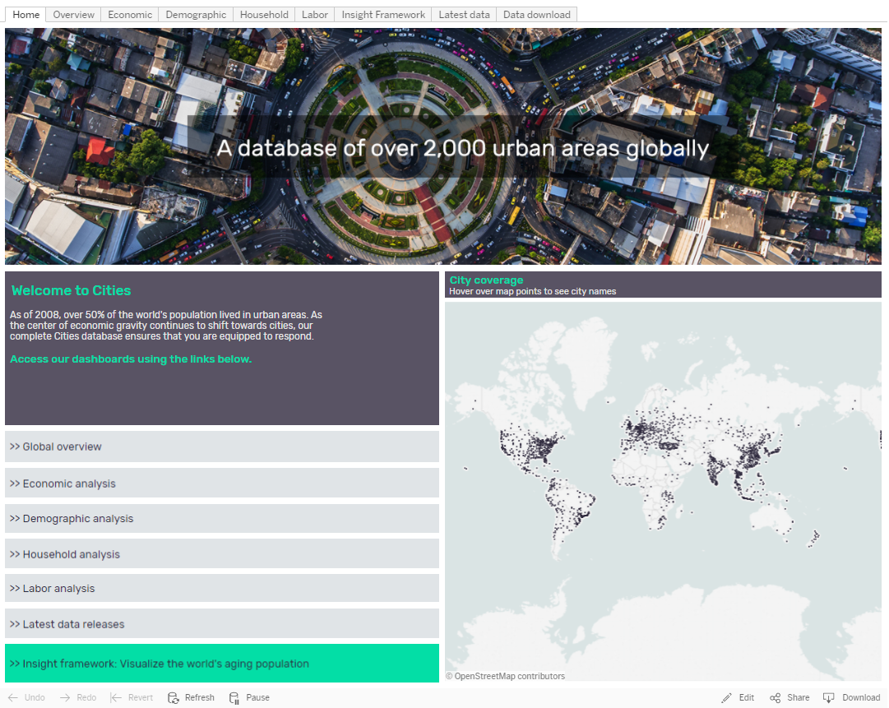

Overview Dashboard
Once on the ‘Overview’ page you will find top level indicators visualized geographically, with a supporting data table.
- In order to quickly find data for your geographical preference, you will find the geographic filters ‘Region’, ‘Country’ and ‘City’ along the left hand side bar. You can select single or multiple geographies at any one time
- Using the ‘Indicator’ and ‘Year’ filters, you can find data on close to 30 indicators for your year of choice
- You will also find city category filters, which allow data selections to be filtered by size of a city’s population or economy
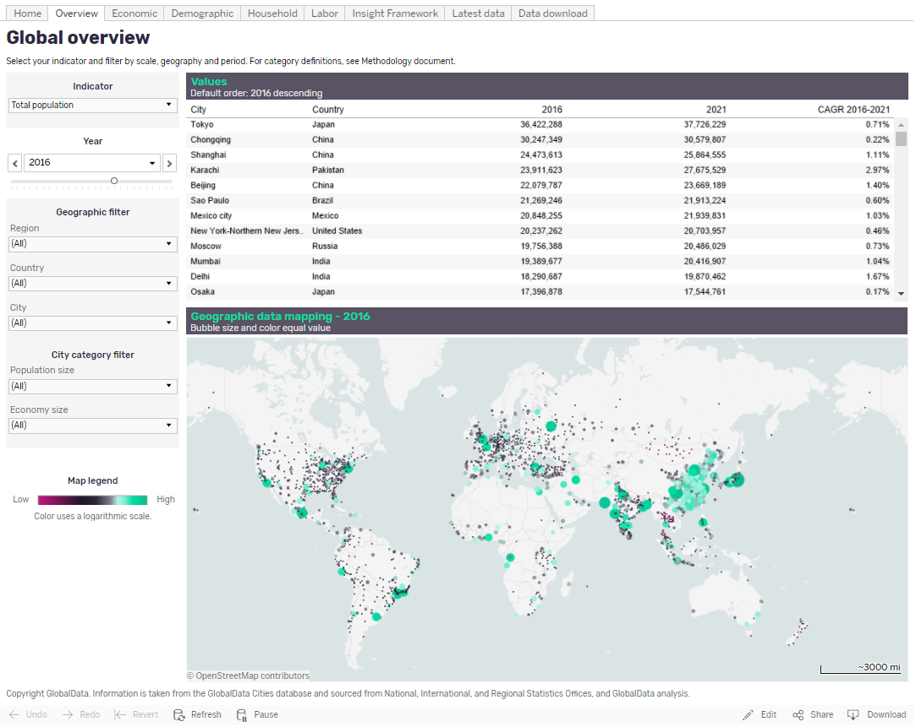
When you have made your selections, e.g. ‘East Asia & Pacific’ as per below, click ‘Apply’
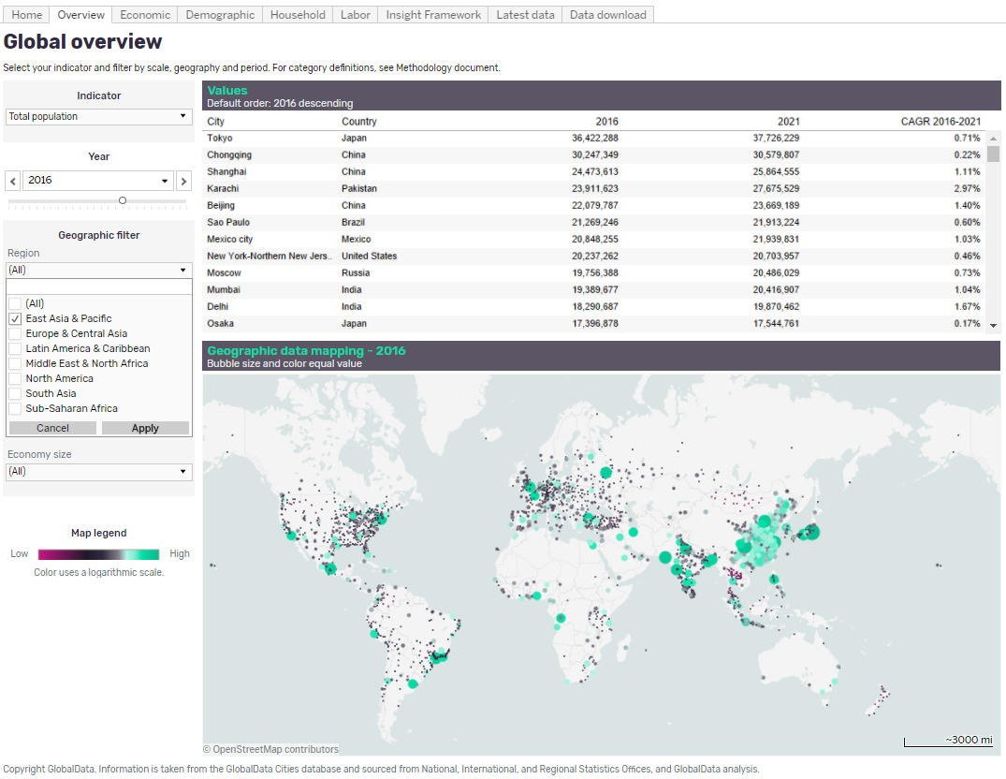
Once you have clicked ‘Apply’, you will see the chart, legend and side bar will update accordingly.

Additional features:
- If you hover over any data point with the cursor, this will show more information for that particular data value
- If you wish to download a map, chart or data point via Tableau Workbook, PDF, data cut or image, you will first need to click on the map, chart or data point which you wish to download, then select the ‘Download’ button in the bottom right corner of the page and choose the format in which you would like the data to be downloaded. To see the underlying data, it is recommended that you select ‘Crosstab’
- To undo your most recent action, click ‘Undo’
- To undo all of your actions, click ‘Revert’

Economic, Demographic, and Household Dashboards
The layout of the ‘Economic’, ‘Demographic’, ‘Household’ and ‘Labor’ dashboards is the same as the ‘Overview’ dashboard seen in the previous section.

Economic dashboard
This dashboard has over 50 indicators to choose from, including GDP and employment sector breakdown
On the bottom half of the dashboard you will find a chart showing the ranking of every city within your selection for your chosen indicator, from 2000 to 2025

Demographic dashboard
The dashboard has over 100 indicators to choose from, including five year age brackets by gender
On the right hand side of the dashboard you will find a population pyramid showing age band breakdown by gender, for 2016 and 2021. This is an aggregation of your selected cities
Along the bottom of the dashboard, population pyramids show the same but by region

Household dashboard
This dashboard has over 20 indicators to choose from, including average household size and mean household income
The top row of charts shows the top 200 cities for your chosen indicator as a bubble chart, and household income distribution aggregated across your selected indicators
Below, the values are mapped geographically for your chosen year

Labor dashboard
This dashboard has 11 indicators to choose from, including employment by sector and labor force participation rate
The top row of charts is fixed to show employment by sector for your chosen year and unemployment rate over time
Below, your chosen indicator is mapped geographically for further analysis

Insight Framework
The ‘Insight Framework’ tab allows you to explore nuances in the data and create your own data story
- Each month, we provide a new chart that presents interesting data in a novel way. For example, June’s chart explores the impact of aging populations
- Navigate through each month’s chart by clicking through the buttons along the top of the dashboard, or using the arrows directly
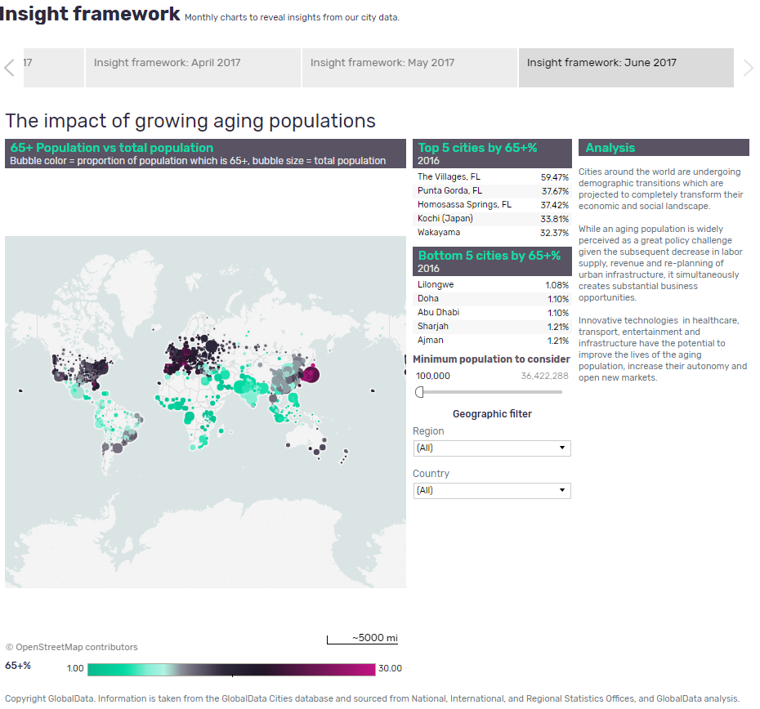

Latest Data Page
As MarketLine is committed to providing clients with the most relevant and up-to-date data available, we will regularly be updating our data set. Clients can visit the ‘Latest data’ tab to keep abreast of all the latest data changes we have made.
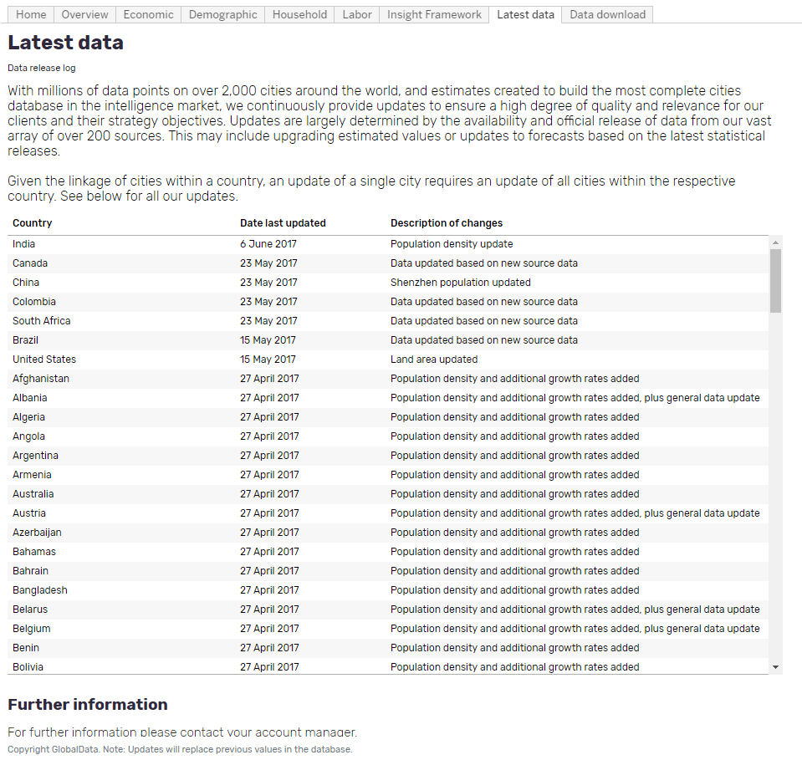

Data Download Page
The ‘Data Download’ dashboard provides the same data available on the other dashboards, but on this page all the indicators are available to select multiple indicators for multiple years. Update the indicator selection as per your preferences using the filters in the left hand side bar, and then download as an Excel file.
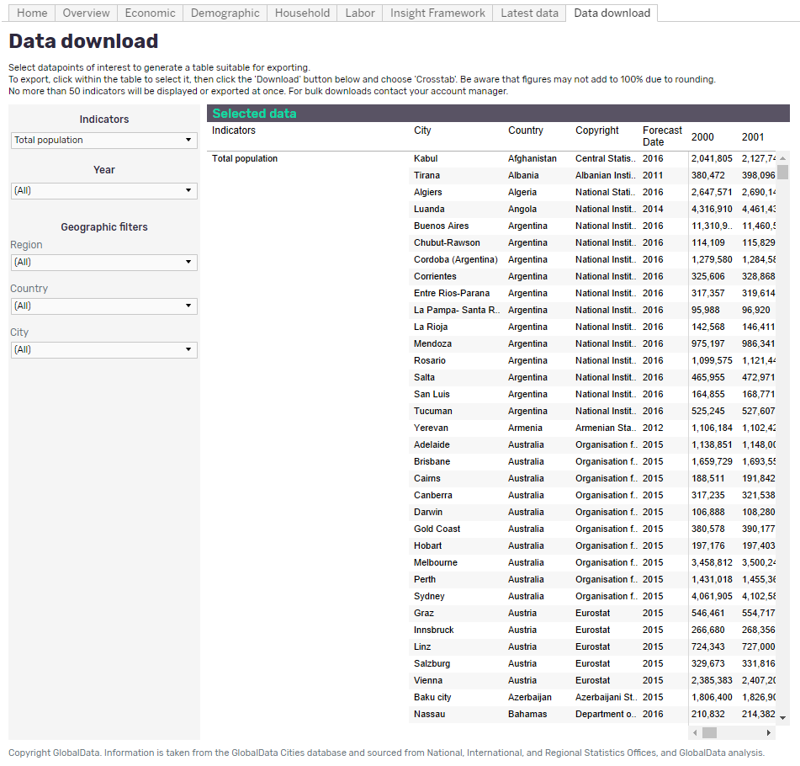
- The data will be shown, along with country and sourcing information in the table to the right
- To download the data click within the table to ‘activate’ it, navigate to the bottom right of the screen and click on the ‘Download’ button. From here you can export the data as ‘Crosstab’ (recommended), PDF, image and so on
- To ensure a swifter user experience, downloads are limited to 50 indicators at a time

Definitions

Indicator definitions
An extensive list of our indicators and their definitions, and routes to calculation, can be found in the Appendix. A summary is below:

Economy
Economy – Total Nominal GDP
- Total consumption (or demand) of an economy. Nominal GDP is provided in current market US Dollars (USD), Purchasing Power Parity (PPP), Local Currency (LCU), plus per capita and annual growth values.
Economy – Total Nominal GVA
- Total Gross Value Added is a measure of the value of goods and services produced in an area, industry or sector of an economy. Nominal GVA is provided in current market US Dollars (USD), Local Currency (LCU), plus per capita and annual growth values.
Economy - Agriculture Nominal GVA
- Total Gross Value Added for the agriculture sector within an economy which includes forestry, hunting, fishing, as well as cultivation of crops and livestock production.
Economy – Industry Nominal GVA
- Total Gross Value added for the industry sector includes manufacturing, mining and utilities (mining and quarrying, manufacturing, electricity/metro, gas, steam and air conditioning supply, water supply and waste management) and construction (construction of buildings, civil engineering and other constructions).
Economy – Services Nominal GVA
- Total Gross Value added for the services sector includes wholesale and retail trade; accommodation and food services; transport; information and communication (wholesale and retail trade; repair of motor vehicles and motorcycles, transportation and storage, accommodation and good service activities and information and communication); financial intermediation and real estate (financial and insurance activities, real estate activities and professional, scientific and technical activities, administrative and support service activities) public administration; education; health and other services (public administration and defense, compulsory social security, education, human health and social work activities, arts, entertainment and recreation, other service activities, activities of households as employers; undifferentiated goods and services producing activities of households for own use and activities of extraterritorial organizations and bodies).
Economy - Real GDP - Index (2010 = 100)
- Real GDP factors in the price-level (or inflation); GDP growth is anchored to a base year to demonstrate growth from a certain period.
Economy - Prices - Consumer price index (2010 = 100)
- Consumer price index presents the growth of the average price level for a basket of good used by consumers. Price level growth is anchored to a base year to demonstrate change from historical periods. We specifically look at the annual average CPI rate.

Demographics
Demographics - Education – Less than Secondary Education
- Total population aged 25+ whose highest education attainment level is primary education or less.
Demographics - Education - Secondary Education
- Total population aged 25+ whose highest education attainment level is secondary education.
Demographics - Education structure - Further Education
- Total population aged 25+ whose highest education attainment level is tertiary education, this includes college, university, technical, masters, PhD etc.
Demographics - Population
- Total population of both males and females. Five year age bands (0-4, 5-9, 10-14 etc) are additionally provided.
Demographics - Population - Male
- Total population of males. Five year age bands (0-4, 5-9, 10-14 etc) are additionally provided.
Demographics - Population - Female
- Total population of females. Five year age bands (0-4, 5-9, 10-14 etc) are additionally provided.

Employment
Employment - Labor force
- The labor force is the supply of labor available for producing goods and services in an economy. It includes people who are currently employed and people who are unemployed but seeking work as well as first-time job-seekers. In many cases, not everyone who works is included. Unpaid workers, family workers, and students are often omitted, and some countries do not count members of the armed forces.
Employment - Labor Force - Participation rate
- Labor force participation rate is the percent of the working age population (15-64 years) who are in the labor force, meaning they are either employed or actively seeking employment.
Employment - Employment
- Total year-end number of people who are employed within an economy, totaling the agriculture, industry and service sectors.
Employment - Employment - Agriculture
- Total year-end number of people who are employed in the agriculture sector within a city, which includes forestry, hunting, fishing as well as cultivation of crops and livestock production.
Employment - Employment - Industry
- Total year-end number of people who are employed in the industry sector within a city, which includes mining and quarrying, manufacturing, electricity/metro, gas, steam and air conditioning supply, water supply and waste management and construction.
Employment - Employment - Services
- Total year-end number of people who are employed in the service sector within a city, which includes wholesale and retail trade; repair of motor vehicles and motorcycles, transportation and storage, accommodation and food service activities, information and communication, financial and insurance activities, real estate activities, professional, scientific and technical activities, administrative and support service activities, public administration and defense; compulsory social security, education, human health and social work activities, arts, entertainment and recreation, other service activities, activities of households as employers; undifferentiated goods- and services-producing activities of households for own use and activities of extraterritorial organizations and bodies.
Employment - Unemployment
- Total number of people who are not employed within the labor force. This excludes economically active activities such as housework and education.
Employment - Unemployment - Unemployment rate
- Unemployment refers to the share of the labor force that is without work but available for and seeking employment.

Households
Households and income - Average household size
- Average number of people living in one household.
Households and income - Total number of households
- “Households” includes all of the occupied housing units in an urban area. A housing unit can include a house, flat, mobile home etc.
Households and income - Household income - Mean household income
- An averaged measure of the combined incomes of all people sharing a particular household or place of residence within the respective year. It includes every form of income, e.g., salaries and wages, retirement income, near cash government transfers like food stamps, and investment gains.
Households and income - Household income - Median household income
- The median income level of the income distribution represents the mid-point at which 50% of households have higher or lower income.
Households and income - Household income – Households by income bracket
- The number of households within a given income bracket. Values are provided in PPP, showing pre-tax income, per annum.
Households and income - Household consumption expenditure
- A measure of the total final consumption expenditure from all households on goods and services.
Households and income - Household consumption expenditure - Expenditure per household
- An average measure of final consumption expenditure by a household on goods and services, measured by the average sum of expenditure of all people occupying a single household.

Geographical definitions
Due to our process of standardization we cover urban areas of varying sizes. Definitions for what constitutes each are below:

City definition: The definition of a city can vary depending on the country, but a city is typically a large urban area or an area with a high concentration of human settlement. A city can be categorized depending on the size of the population:
- Megacities: Cities with populations of 10 million and more.
- Large cities: Cities with populations of between 5 million and less than 10 million.
- Medium-sized cities: Cities with populations of between 500,000 and less than 5 million.
- Small cities: Cities with populations of less than 500,000.
Metropolitan area definition: A metropolitan area is typically defined as a region which consists of a densely populated urban center and the surrounding regions which are connected via transport networks, this includes areas within the direct commuter belt.
Municipality definition: A municipality is typically an urban area which has its own local government with local jurisdiction and corporate status.
Region definition: A region is often defined as a breakdown or categorization of a country into large areas which have definable boundaries, an example is counties such as West Midlands within the UK, or a country could be split into large general regions such as North and South Island in New Zealand.

Methodology and Frequently Asked Questions

Sourcing, quality and confidence

Where do you collect your data from?
National statistic offices are our main source of information, supported by international and regional statistical offices, and international charities, such as UNICEF. Using statistical offices which represent the country, or city, in question ensures access to the best and most up-to-date data available.

How trustworthy is your data?
Our credibility is driven by our data sources and our modelling methodology. Official statistics offices can typically be trusted as they are a either a governmental department or highly regarded independent organization which may report to the national government, or on their behalf. If we have low confidence in a source data point, regardless of the general credibility of the source, we carry out a secondary checking procedure to verify or discount the datWe maintain a level of transparency on such issues by providing information on our sources.

What kind of quality control measures do you implement?
To ensure the highest quality data possible, quality checks are implemented at every stage of the end-to-end process. We ensure the validity of our data with numerous automated tests, as well as manual checking of data points and overall trends. Additionally, we regularly re-evaluate our modelling logic to ensure we are continually enhancing our understanding of how intelligence on cities should be represented.

How do you ensure consistency in the definitions when your data is from multiple sources?
A consistent and robust dataset is of paramount importance. All source definitions are checked thoroughly before the data is extracted to ensure consistency and an estimation approach is implemented if absolutely necessary. To ensure there are no disparities in economic definitions we collect nominal GDP at current prices for each city, and use standardized currency conversions where needed.

How do you overcome gaps in source data?
We use a variety of techniques depending on the severity of data availability however, in simple cases, we are able to impute missing values by using linear trend methods, which produces the lowest standard error.

How confident can you be in your data for obscure or less-developed markets?
Where we are unsure of the reliability of a data source we ensure figures are aligned with secondary materials. Beyond this, our hierarchical modelling approach enables us to credibly provide estimations for hard-to-research markets.

Forecasting

How do you forecast your data?
Broadly, our principal assumption is that cities are by-in-large becoming independent entities within countries, therefore forecasting of cities should be carried out with a stronger emphasis on their independent nature (or growth). Nonetheless, we still analyze cities within its country limits (for instance, taking into account the historical city’s growth contribution to the country). Our forecast method therefore consists of a rigorous framework relevant to the city and data availability at hand, and uses exponential smoothing and linear regression techniques to derive future values. This method removes short-term volatility through dampening, giving an outlook on long-term growth. This long-term outlook is an essential condition given the high degree of estimation in micro data by official sources.

How are your exchange rates forecast?
The latest year is estimated by taking into account year-to-date data; while the forecast is derived using International Monetary Fund implied exchange rates.

Update cycles

How often do you update your data?
Our team of Researchers and Analysts follow an annual update cycle, while continually seeking new cities and indicators to add to our coverage.

How do you ensure you are aware of any revised data or new data releases?
Our Analysts keep a record of source data cycles to ensure that when a source’s data is revised our data set is also updated.

Coverage

How do you choose your cities?
We have chosen our markets based on what is most valuable to clients. This means we cover both the biggest cities and those that are growing and have great potential for the future; it also ensures that we only cover markets where we can be confident in the quality of our data and our ability to provide complete, geographically comparable values.

How do you choose your indicators?
To meet our goal of creating the most comprehensive cities database in the market we have selected our indicators based on reliability and depth of the data available, usefulness in making business decisions, and client feedback.

Why do the area definitions of some cities differ?
In order to provide the most accurate indication of a city’s economy or demographic situation, for example, we will try to collate data for the city proper. If such data is unavailable, or cannot be credibly estimated, we will attempt to use the ‘next best’ definition, i.e. metropolitan area, metropolitan region, and so on. Improvements to our methodology mean we have now been able to provide data on a city level where we were unable to before.

Why do you not provide data on populations with “No Education”?
Due to disparities between definitions of education levels across different countries, and the varying levels of data availability we provide data on those achieving “Less than secondary education.” This allows us to maintain consistency in our taxonomy and provide data with higher confidence.

Why do you estimate GVA structure as opposed to GDP?
Gross Value Added is a more valuable representation of the contribution of a given industry or sector to the total economy. GVA is calculated by removing subsidies and taxes from GDP, factors which may differ significantly, creating false or enhanced figures.

General data questions

Why are the values in your database different to other sources?
The data points that our competitors provide may vary depending on a variety of factors, for instance, there may be a difference in the city area definition, or a different update period, or a different source of datOur approach is focused on providing the most complete database on cities within the market, which may not necessarily be the same motivation of our competitors, as we strongly believe there is a need to enable comparative analysis across cities (in similar fashion to how countries are analyzed).

If you have any queries or need further information please contact your account manager.

Appendix

Complete indicator list

Economy
Nominal GDP (m) – Total (USD, LCU)
Nominal GDP - Annual growth (%)
Nominal GDP - Per capita (USD, LCU)
Nominal GDP - Per capita: annual growth (%)
Nominal GDP - Per km2 (USD, LCU)
Nominal GDP - Per employed person (USD, LCU)
Nominal GDP - Per employed person: annual growth (%)
Nominal GDP (PPP, m) - Total
Nominal GDP (PPP) - Annual growth (%)
Nominal GDP (PPP) - Per capita
Nominal GDP (PPP) - Per capita: annual growth (%)
Nominal GDP (PPP) - Per km2
Nominal GDP (PPP) - Per employed person
Nominal GDP (PPP) - Per employed person: annual growth (%)
Real GDP (m) - Total (2010 = 100) (USD, LCU)
Real GDP - Annual growth (%)
Real GDP - Per Capita (2010 = 100) (USD, LCU)
Real GDP - Index (2010 = 100)
Real GDP - Per employed person (2010 = 100) (USD, LCU)
Real GDP - Per employed person: annual growth (%)
Real GDP - Per km2 (USD, LCU)
Nominal GVA (m) - Total (USD, LCU)
Nominal GVA - Annual growth (%) - Total
Nominal GVA (m) - Agriculture - Total (USD, LCU)
Nominal GVA structure (% of total) - Agriculture
Nominal GVA - Agriculture - Per agriculture employee
Nominal GVA (m) - Industry - Total (USD, LCU)
Nominal GVA (m) - Industry - Construction (USD, LCU)
Nominal GVA (m) - Industry - Manufacturing, mining & utilities (USD, LCU)
Nominal GVA structure (% of total) - Industry - Total
Nominal GVA structure (% of total) - Industry - Construction
Nominal GVA structure (% of total) - Industry - Manufacturing, mining & utilities
Nominal GVA - Industry - Per industry employee (USD, LCU)
Nominal GVA (m) - Services - Total (USD, LCU)
Nominal GVA (m) - Services - Financial, insurance, real estate, professional, scientific, technical, and administrative activities (USD, LCU)
Nominal GVA (m) - Services - Public administration, education, health, and other services (USD, LCU)
Nominal GVA (m) - Services - Wholesale and retail trade, accommodation and food services, and transport, information, and communication (USD, LCU)
Nominal GVA structure (% of total) - Services - Total
Nominal GVA structure (% of total) - Services - Financial, insurance, real estate, professional, scientific, technical, and administrative activities
Nominal GVA structure (% of total) - Services - Public administration, education, health, and other services
Nominal GVA structure (% of total) - Services - Wholesale and retail trade, accommodation and food services, and transport, information, and communication
Nominal GVA - Services - Per services employee (USD, LCU)
Nominal GVA - Annual growth (%) - Agriculture - Total
Nominal GVA - Annual growth (%) - Industry - Total
Nominal GVA - Annual growth (%) - Services - Total
Nominal GVA - Annual growth (%) - Industry - Construction
Nominal GVA - Annual growth (%) - Industry - Manufacturing, mining & utilities
Nominal GVA - Annual growth (%) - Services - Financial, insurance, real estate, professional, scientific, technical, and administrative activities
Nominal GVA - Annual growth (%) - Services - Public administration, education, health, and other services
Nominal GVA - Annual growth (%) - Services - Wholesale and retail trade, accommodation and food services, and transport, information, and communication
Nominal GVA - Annual growth (%) - Agriculture - Per agriculture employee
Nominal GVA - Annual growth (%) - Industry - Per industry employee
Nominal GVA - Annual growth (%) - Services - Per services employee
Prices - Consumer price index (2010 = 100) - Overall
Prices - Annual growth (%) – Overall

Demographic
Population - Total
Population - Annual growth (%)
Population - Population density
Population - Under 15 years - Total
Population - Under 15 years - Annual growth (%)
Population - Under 15 years - Aged 0-4 years
Population - Under 15 years - Aged 5-9 years
Population - Under 15 years - Aged 10-14 years
Population - Under 15 years - Aged 0-4 years: annual growth (%)
Population - Under 15 years - Aged 5-9 years: annual growth (%)
Population - Under 15 years - Aged 10-14 years: annual growth (%)
Population - 15-64 years - Total
Population - 15-64 years - Annual growth (%)
Population - 15-64 years - Aged 15-19 years
Population - 15-64 years - Aged 20-24 years
Population - 15-64 years - Aged 25-29 years
Population - 15-64 years - Aged 30-34 years
Population - 15-64 years - Aged 35-39 years
Population - 15-64 years - Aged 40-44 years
Population - 15-64 years - Aged 45-49 years
Population - 15-64 years - Aged 50-54 years
Population - 15-64 years - Aged 55-59 years
Population - 15-64 years - Aged 60-64 years
Population - 15-64 years - Aged 15-19 years: annual growth (%)
Population - 15-64 years - Aged 20-24 years: annual growth (%)
Population - 15-64 years - Aged 25-29 years: annual growth (%)
Population - 15-64 years - Aged 30-34 years: annual growth (%)
Population - 15-64 years - Aged 35-39 years: annual growth (%)
Population - 15-64 years - Aged 40-44 years: annual growth (%)
Population - 15-64 years - Aged 45-49 years: annual growth (%)
Population - 15-64 years - Aged 50-54 years: annual growth (%)
Population - 15-64 years - Aged 55-59 years: annual growth (%)
Population - 15-64 years - Aged 60-64 years: annual growth (%)
Population - 65+ years - Total
Population - 65+ years - Annual growth (%)
Population - 65+ years - Aged 65-69 years
Population - 65+ years - Aged 70-74 years
Population - 65+ years - Aged 75-79 years
Population - 65+ years - Aged 80+ years
Population - 65+ years - Aged 65-69 years: annual growth (%)
Population - 65+ years - Aged 70-74 years: annual growth (%)
Population - 65+ years - Aged 75-79 years: annual growth (%)
Population - 65+ years - Aged 80+ years: annual growth (%)
Population - Male - Total
Population - Male - Annual growth (%)
Population - Male - Under 15 years - Total
Population - Male - Under 15 years - Annual growth (%)
Population - Male - Under 15 years - Male: Aged 0-4 years
Population - Male - Under 15 years - Male: Aged 5-9 years
Population - Male - Under 15 years - Male: Aged 10-14 years
Population - Male - Under 15 years - Male: Aged 0-4 years: annual growth (%)
Population - Male - Under 15 years - Male: Aged 5-9 years: annual growth (%)
Population - Male - Under 15 years - Male: Aged 10-14 years: annual growth (%)
Population - Male - 15-64 years - Total
Population - Male - 15-64 years - Annual growth (%)
Population - Male - 15-64 years - Male: Aged 15-19 years
Population - Male - 15-64 years - Male: Aged 20-24 years
Population - Male - 15-64 years - Male: Aged 25-29 years
Population - Male - 15-64 years - Male: Aged 30-34 years
Population - Male - 15-64 years - Male: Aged 35-39 years
Population - Male - 15-64 years - Male: Aged 40-44 years
Population - Male - 15-64 years - Male: Aged 45-49 years
Population - Male - 15-64 years - Male: Aged 50-54 years
Population - Male - 15-64 years - Male: Aged 55-59 years
Population - Male - 15-64 years - Male: Aged 60-64 years
Population - Male - 15-64 years - Male: Aged 15-19 years: annual growth (%)
Population - Male - 15-64 years - Male: Aged 20-24 years: annual growth (%)
Population - Male - 15-64 years - Male: Aged 25-29 years: annual growth (%)
Population - Male - 15-64 years - Male: Aged 30-34 years: annual growth (%)
Population - Male - 15-64 years - Male: Aged 35-39 years: annual growth (%)
Population - Male - 15-64 years - Male: Aged 40-44 years: annual growth (%)
Population - Male - 15-64 years - Male: Aged 45-49 years: annual growth (%)
Population - Male - 15-64 years - Male: Aged 50-54 years: annual growth (%)
Population - Male - 15-64 years - Male: Aged 55-59 years: annual growth (%)
Population - Male - 15-64 years - Male: Aged 60-64 years: annual growth (%)
Population - Male - 65+ years - Total
Population - Male - 65+ years - Annual growth (%)
Population - Male - 65+ years - Male: Aged 65-69 years
Population - Male - 65+ years - Male: Aged 70-74 years
Population - Male - 65+ years - Male: Aged 75-79 years
Population - Male - 65+ years - Male: Aged 80+ years
Population - Male - 65+ years - Male: Aged 65-69 years: annual growth (%)
Population - Male - 65+ years - Male: Aged 70-74 years: annual growth (%)
Population - Male - 65+ years - Male: Aged 75-79 years: annual growth (%)
Population - Male - 65+ years - Male: Aged 80+ years: annual growth (%)
Population - Female - Total
Population - Female - Annual growth (%)
Population - Female - Under 15 years - Total
Population - Female - Under 15 years - Annual growth (%)
Population - Female - Under 15 years - Female: Aged 0-4 years
Population - Female - Under 15 years - Female: Aged 5-9 years
Population - Female - Under 15 years - Female: Aged 10-14 years
Population - Female - Under 15 years - Female: Aged 0-4 years: annual growth (%)
Population - Female - Under 15 years - Female: Aged 5-9 years: annual growth (%)
Population - Female - Under 15 years - Female: Aged 10-14 years: annual growth (%)
Population - Female - 15-64 years - Total
Population - Female - 15-64 years - Annual growth (%)
Population - Female - 15-64 years - Female: Aged 15-19 years
Population - Female - 15-64 years - Female: Aged 20-24 years
Population - Female - 15-64 years - Female: Aged 25-29 years
Population - Female - 15-64 years - Female: Aged 30-34 years
Population - Female - 15-64 years - Female: Aged 35-39 years
Population - Female - 15-64 years - Female: Aged 40-44 years
Population - Female - 15-64 years - Female: Aged 45-49 years
Population - Female - 15-64 years - Female: Aged 50-54 years
Population - Female - 15-64 years - Female: Aged 55-59 years
Population - Female - 15-64 years - Female: Aged 60-64 years
Population - Female - 15-64 years - Female: Aged 15-19 years: annual growth (%)
Population - Female - 15-64 years - Female: Aged 20-24 years: annual growth (%)
Population - Female - 15-64 years - Female: Aged 25-29 years: annual growth (%)
Population - Female - 15-64 years - Female: Aged 30-34 years: annual growth (%)
Population - Female - 15-64 years - Female: Aged 35-39 years: annual growth (%)
Population - Female - 15-64 years - Female: Aged 40-44 years: annual growth (%)
Population - Female - 15-64 years - Female: Aged 45-49 years: annual growth (%)
Population - Female - 15-64 years - Female: Aged 50-54 years: annual growth (%)
Population - Female - 15-64 years - Female: Aged 55-59 years: annual growth (%)
Population - Female - 15-64 years - Female: Aged 60-64 years: annual growth (%)
Population - Female - 65+ years - Total
Population - Female - 65+ years - Annual growth (%)
Population - Female - 65+ years - Female: Aged 65-69 years
Population - Female - 65+ years - Female: Aged 70-74 years
Population - Female - 65+ years - Female: Aged 75-79 years
Population - Female - 65+ years - Female: Aged 80+ years
Population - Female - 65+ years - Female: Aged 65-69 years: annual growth (%)
Population - Female - 65+ years - Female: Aged 70-74 years: annual growth (%)
Population - Female - 65+ years - Female: Aged 75-79 years: annual growth (%)
Population - Female - 65+ years - Female: Aged 80+ years: annual growth (%)
Population structure (% of total) - Under 15 years - Total
Population structure (% of total) - Under 15 years - Aged 0-4 years
Population structure (% of total) - Under 15 years - Aged 5-9 years
Population structure (% of total) - Under 15 years - Aged 10-14 years
Population structure (% of total) - 15-64 years - Total
Population structure (% of total) - 15-64 years - Aged 15-19 years
Population structure (% of total) - 15-64 years - Aged 20-24 years
Population structure (% of total) - 15-64 years - Aged 25-29 years
Population structure (% of total) - 15-64 years - Aged 30-34 years
Population structure (% of total) - 15-64 years - Aged 35-39 years
Population structure (% of total) - 15-64 years - Aged 40-44 years
Population structure (% of total) - 15-64 years - Aged 45-49 years
Population structure (% of total) - 15-64 years - Aged 50-54 years
Population structure (% of total) - 15-64 years - Aged 55-59 years
Population structure (% of total) - 15-64 years - Aged 60-64 years
Population structure (% of total) - 65+ years - Total
Population structure (% of total) - 65+ years - Aged 65-69 years
Population structure (% of total) - 65+ years - Aged 70-74 years
Population structure (% of total) - 65+ years - Aged 75-79 years
Population structure (% of total) - 65+ years - Aged 80+ years
Population structure (% of total) - Male - Total
Population structure (% of total) - Male - Under 15 years - Total
Population structure (% of total) - Male - Under 15 years - Male: Aged 0-4 years
Population structure (% of total) - Male - Under 15 years - Male: Aged 5-9 years
Population structure (% of total) - Male - Under 15 years - Male: Aged 10-14 years
Population structure (% of total) - Male - 15-64 years - Total
Population structure (% of total) - Male - 15-64 years - Male: Aged 15-19 years
Population structure (% of total) - Male - 15-64 years - Male: Aged 20-24 years
Population structure (% of total) - Male - 15-64 years - Male: Aged 25-29 years
Population structure (% of total) - Male - 15-64 years - Male: Aged 30-34 years
Population structure (% of total) - Male - 15-64 years - Male: Aged 35-39 years
Population structure (% of total) - Male - 15-64 years - Male: Aged 40-44 years
Population structure (% of total) - Male - 15-64 years - Male: Aged 45-49 years
Population structure (% of total) - Male - 15-64 years - Male: Aged 50-54 years
Population structure (% of total) - Male - 15-64 years - Male: Aged 55-59 years
Population structure (% of total) - Male - 15-64 years - Male: Aged 60-64 years
Population structure (% of total) - Male - 65+ years - Total
Population structure (% of total) - Male - 65+ years - Male: Aged 65-69 years
Population structure (% of total) - Male - 65+ years - Male: Aged 70-74 years
Population structure (% of total) - Male - 65+ years - Male: Aged 75-79 years
Population structure (% of total) - Male - 65+ years - Male: Aged 80+ years
Population structure (% of total) - Female - Total
Population structure (% of total) - Female - Under 15 years - Total
Population structure (% of total) - Female - Under 15 years - Female: Aged 0-4 years
Population structure (% of total) - Female - Under 15 years - Female: Aged 5-9 years
Population structure (% of total) - Female - Under 15 years - Female: Aged 10-14 years
Population structure (% of total) - Female - 15-64 years - Total
Population structure (% of total) - Female - 15-64 years - Female: Aged 15-19 years
Population structure (% of total) - Female - 15-64 years - Female: Aged 20-24 years
Population structure (% of total) - Female - 15-64 years - Female: Aged 25-29 years
Population structure (% of total) - Female - 15-64 years - Female: Aged 30-34 years
Population structure (% of total) - Female - 15-64 years - Female: Aged 35-39 years
Population structure (% of total) - Female - 15-64 years - Female: Aged 40-44 years
Population structure (% of total) - Female - 15-64 years - Female: Aged 45-49 years
Population structure (% of total) - Female - 15-64 years - Female: Aged 50-54 years
Population structure (% of total) - Female - 15-64 years - Female: Aged 55-59 years
Population structure (% of total) - Female - 15-64 years - Female: Aged 60-64 years
Population structure (% of total) - Female - 65+ years - Total
Population structure (% of total) - Female - 65+ years - Female: Aged 65-69 years
Population structure (% of total) - Female - 65+ years - Female: Aged 70-74 years
Population structure (% of total) - Female - 65+ years - Female: Aged 75-79 years
Population structure (% of total) - Female - 65+ years - Female: Aged 80+ years
Population - Dependency ratio - Non-working to working age population
Population - Dependency ratio - Over 64 to working age population
Population - Dependency ratio - Under 15 to working age population
Population - Dependency ratio - Non-working to working age population: annual growth (%)
Population - Dependency ratio - Over 64 to working age population: annual growth (%)
Population - Dependency ratio - Under 15 to working age population: annual growth (%)
Education - Secondary education - Total
Education - Further education - Total
Education - Less than Secondary education - Total
Education structure (% of total) - Less than Secondary education
Education structure (% of total) - Secondary education
Education structure (% of total) - Further education
Education - Less than Secondary education - Annual growth (%)
Education - Secondary education - Annual growth (%)
Education - Further education - Annual growth (%)

Employment
Total
Total - Annual growth (%)
Agriculture
Agriculture - Annual growth (%)
Industry
Industry - Annual growth (%)
Services
Services - Annual growth (%)
Employment structure (% of total) - Agriculture
Employment structure (% of total) - Industry
Employment structure (% of total) - Services
Labour force - Total
Labour force - Total - Annual growth (%)
Labour force - Participation rate
Labour force - Participation rate - Annual growth (%)
Unemployment - Total
Unemployment - Total - Annual growth (%)
Unemployment - Unemployment rate
Unemployment - Unemployment rate - Annual growth (%)

Households
Total number of households
Total number of households - Annual growth (%)
Household density
Average household size
Average household size - Annual growth (%)
Household final consumption expenditure - Total (USD, LCU)
Household final consumption expenditure - Annual growth (%)
Household final consumption expenditure - Mean household expenditure (USD, LCU)
Household final consumption expenditure - Mean household expenditure - Annual growth (%)
Household income - Mean household income (USD, LCU)
Household income - Mean household income - Annual growth (%)
Household income - Median household income (USD, LCU)
Household income - Median household income - Annual growth (%)
Number of households by income brackets - PPP0-1,999
Number of households by income brackets - PPP2,000-3,999
Number of households by income brackets - PPP4,000-9,999
Number of households by income brackets - PPP10,000-19,999
Number of households by income brackets - PPP20,000-39,999
Number of households by income brackets - PPP40,000-74,999
Number of households by income brackets - PPP75,000+
Household income structure (% of total) - By income bracket: PPP0-1,999
Household income structure (% of total) - By income bracket: PPP2,000-3,999
Household income structure (% of total) - By income bracket: PPP4,000-9,999
Household income structure (% of total) - By income bracket: PPP10,000-19,999
Household income structure (% of total) - By income bracket: PPP20,000-39,999
Household income structure (% of total) - By income bracket: PPP40,000-74,999
Household income structure (% of total) - By income bracket: PPP75,000+

Complete geography list

EAST ASIA & PACIFIC
Australia
Adelaide | Brisbane | Cairns
Canberra | Darwin | Gold Coast-Tweed Heads
Hobart | Melbourne | Perth
Sydney

Cambodia
Phnom Penh

China
China
Ankang | Anqing | Anshan
Anshun | Anyang | Baicheng
Baise | Baishan | Baiyin
Baoding | Baoji | Baoshan
Bazhong | Beihai | Beijing
Bengbu | Benxi | Binzhou
Bozhou | Cangzhou | Changchun
Changde | Changsha | Changzhi
Changzhou | Chaohu | Chaoyang
Chaozhou | Chengde | Chengdu
Chenzhou | Chifeng | Chizhou
Chongqing | Chongzuo | Chuzhou
Dalian | Dandong | Daqin
Datong | Dazhou | Deyang
Dezhou | Dingxi | Dongguan
Dongying | Ezhou | Fangchenggang
Foshan | Fushun | Fuxin
Fuyang | Fuzhou | Ganzhou
Guang'an | Guangyuan | Guangzhou
Guigang | Guilin | Guiyang
Guyuan | Haikou | Handan
Hangzhou | Hanzhong | Harbin
Hebi | Hechi | Hefei
Hegang | Heihe | Hengshui
Hengyang | Heyuan | Heze
Hezhou | Hohhot | Hong Kong
Huaian | Huaibei | Huaihua
Huainan | Huanggang | Huangshan
Huangshi | Huizhou | Huludao
Hulunbuir | Huzhou | Jiamusi
Ji'an | Jiaozuo | Jiaxing
Jiayuguan | Jieyang | Jilin
Jinan | Jinchang | Jincheng
Jingdezhen | Jingmen | Jingzhou
Jinhua | Jining | Jinzhong
Jinzhou | Jiujiang | Jiuquan
Jixi | Kaifeng | Kunming
Laibin | Langfang | Lanzhou
Leshan | Lhasa | Lianyungang
Liaocheng | Liaoyuan | Lijiang
Lincang | Linfen | Linyi
Lishui | Liupanshui | Longyan
Loudi | Lu'an | Luohe
Luoyang | Luzhou | Lyuliang
Maanshan | Maoming | Meishan
Meizhou | Mianyang | Mudanjiang
Nanchang | Nanchong | Nanjing
Nanning | Nanping | Nantong
Nanyang | Neijiang | Ningbo
Ningde | Panjin | Panzhihua
Pingdingshan | Pingliang | Pingxiang
Putian | Puyang | Qingdao
Qingyuan | Qinhuangdao | Qinyang
Qinzhou | Qiqihar | Qitaihe
Quanzhou | Qujing | Quzhou
Rizhao | Sanmenxia | Sanming
Sanya | Shanghai | Shangluo
Shangqiu | Shantou | Shanwei
Shaoguan | Shaoxing | Shaoyang
Shenyang | Shenzhen | Shijiazhuang
Shiyan | Shizuishan | Shuangyashan
Shuozhou | Simao | Siping
Songyuan | Suihua | Suining
Suizhou | Suqian | Suzhou
Tai'an | Taiyuan | Taizhou
Tangshan | Tianjin | Tianshui
Tieling | Tongchuan | Tonghua
Tongliao | Tongling | Urumqi
Weifang | Weihai | Weinan
Wenzhou | Wuhai | Wuhan
Wuhu | Wulanchabu | Wuwei
Wuxi | Wuzhong | Wuzhou
Xiamen | Xi'an | Xiangfan
Xiangtan | Xianning | Xianyang
Xiaogan | Xingtai | Xining
Xinxiang | Xinyang | Xinyu
Xinzhou | Xuancheng | Xuchang
Xuzhou | Yanan | Yancheng
Yangjiang | Yangquan | Yangzhou
Yantai | Yibin | Yichang
Yichun (Heilongjiang) | Yichun (Jiangxi) | Yinchuan
Yingkou | Yingtan | Yiyang
Yongzhou | Yueyang | Yulin (Guangxi)
Yulin (Shanxi) | Yuncheng | Yunfu
Yuxi | Zaozhuang | Zhangjiajie
Zhangjiakou | Zhangye | Zhangzhou
Zhanjiang | Zhaoqin | Zhaotong
Zhengjiang | Zhengzhou | Zhongshan
Zhongwei | Zhoukou | Zhoushan
Zhuhai | Zhumadian | Zhuzhou
Zibo | Zigong | Ziyang

Indonesia
Ambon | Balikpapan | Bandar Lampung
Bandung | Banjarmasin | Bekasi
Bengkulu | Binjai | Bogor
Cilegon | Cimahi | Cirebon
Denpasar | Dumai | Jakarta
Jambi | Jayapura | Jember
Kediri | Kendari | Kupang
Malang | Manado | Mataram
Medan | Palembang | Palu
Pekalongan | Pekan Baru | Pematang Siantar
Pontianak | Probolinggo | Samarinda
Semarang | Serang | Sukabumi
Surabaya | Surakarta | Tangerang
Tasikmalaya | Tegal | Yogyakarta

Japan
Anjo | Fukuoka | Fukuyama
Hamamatsu | Himeji | Hiroshima
Kagoshima | Kanazawa | Kitakyushu
Kochi | Kofu | Kumamoto
Kurashiki | Maebashi | Matsuyama
Mito | Nagano | Nagasaki
Nagoya | Naha | Niigata
Numazu | Oita | Okayama
Osaka | Sapporo | Sendai
Shizuoka | Takamatsu | Tokushima
Tokyo | Toyama | Toyohashi
Utsunomiya | Wakayama | Yokkaichi

Laos
Vientiane

Malaysia
Alor Setar | Ipoh | Johor Bahru
Kajang | Kangar | Kota Bharu
Kota Kinabalu | Kuala Lumpur | Kuala Terengganu
Kuantan | Kuching | Malacca
Miri | Penang | Seremban

Mongolia
Arvaikheer | Bayankhongor | Bayan-Olgii
Bulgan | Choibalsan | Choir-Sumber
Dalanzadgad | Darkhan | Erdenet
Govi-Altai-Yesonbulag | Khovd-Jargalant | Mandalgovi-Saintsagaan
Moron | Ondorkhaan-Kherlen | Sainshand
Selenge-Sukhbaatar | Sukhbaatar-Baruun-Urt | Tsetserleg
Ulaanbaatar | Uvs-Ulaangom | Zavkhan-Uliastai
Zuunmod

Myanmar (Burma)
Nay Pyi Taw

New Zealand
Auckland | Christchurch | Dunedin
Gisborne | Greymouth | Hamilton
Hastings | Invercargill | Nelson
New Plymouth | Tauranga | Wanganui
Wellington | Whangarei

Papua New Guinea
Port Moresby

Philippines
Angeles | Bacolod | Baguio
Batangas | Cagayan de oro | Calamba
Cebu | Dagupan | Davao
General Santos | Iloilo-Guimaras | Manila
Naga | Olongapo | Zamboanga

Singapore
Singapore

South Korea
Busan | Changwon | Cheonan
Cheongju | Chuncheon | Daegu
Daejeon | Gwangju | Incheon
Jeju | Jeonju | Pohang
Seoul | Suwon | Ulsan
Yeosu

Taiwan
Taipei

Thailand
Amnat Charoen | Ang Thong | Bangkok
Buri Ram | Cha-am | Chachoengsao
Chai Nat | Chaiyaphum | Chanthaburi
Chaophraya Surasak | Chiang Mai | Chiang Rai
Chumpon | Hat Yai | Hua Hin
Kalasin | Kamphaeng Phet | Kanchanaburi
Khao Sam Yot | Krabi | Lampang
Lamphun | Loei | Mae Hong Son
Mae Sot | Maha Sarakham | Mukdahan
Nakhon Nayok | Nakhon Pathom | Nakhon Phanom
Nakhon Ratchasima | Nakhon Sawan | Nakhon Si Thammarat
Nan | Narathiwat | Nong Bua Lam Phu
Nong Khai | Nonthaburi | Pattani
Pattaya | Phangnga | Phayao
Phetchabun | Phichit | Phitsanulok
Phra Nakhon Si Ayutthaya | Phrae | Phuket
Prachin Buri | Rangsit | Ranong
Ratchaburi | Rayong | Roi Et
Sa Kaeo | Sakhon Nakhon | Samut Prakhan
Samut Sakhon | Samut Songkhram | Saraburi
Satun | Sawankhalok | Si Sa Ket
Sila | Sing Buri | Suphan Buri
Surat Thani | Surin | Trang
Trat | Ubon Ratchathani | Udon Thani
Uthai Thani | Uttradit | Yala
Yasothon

Vietnam
Hanoi

EUROPE & CENTRAL ASIA
Albania
Tirana

Armenia
Yerevan

Austria
Graz | Innsbruck | Linz
Salzburg | Vienna

Azerbaijan
Baku City

Belarus
Brest | Gomel | Grodno
Minsk | Mogilev | Vitebsk

Belgium
Antwerp | Brussels | Charleroi
Ghent | Liege

Bosnia and Herzegovina
Sarajevo

Bulgaria
Burgas | Plovdiv | Sofia
Varna

Croatia
Split | Zagreb

Cyprus
Lefkosia/Nicosia

Czech Republic
Brno | Ostrava | Plzen
Prague

Denmark
Aalborg | Aarhus | Copenhagen
Odense

Estonia
Tallinn

Finland
Helsinki | Tampere | Turku

France
Amiens | Angers | Avignon
Besancon | Bordeaux | Brest
Caen | Clermont-Ferrand | Dijon
Grenoble | Le Mans | Lens
Lille | Limoges | Lyon
Marseille | Metz | Montpellier
Mulhouse | Nancy | Nantes
Nice | Nimes | Orleans
Paris | Pau | Perpignan
Poitiers | Reims | Rennes
Rouen | Saint-Etienne | Strasbourg
Toulon | Toulouse | Tours

Georgia
Tbilisi

Germany
Aachen | Aschaffenburg | Augsburg
Bayreuth | Berlin | Bielefeld
Bonn | Braunschweig | Braunschweig-Salzgitter-Wolfsburg
Bremen | Bremerhaven | Chemnitz
Cologne | Cottbus | Darmstadt
Dortmund | Dresden | Dusseldorf
Erfurt | Essen | Flensburg
Frankfurt | Freiburg im Breisgau | Giessen
Gorlitz | Gottingen | Halle an der Saale
Hamburg | Hanover | Heidelberg
Heilbronn | Hildesheim | Ingolstadt
Iserlohn | Kaiserslautern | Karlsruhe
Kassel | Kiel | Koblenz
Konstanz | Leipzig | Lubeck
Magdeburg | Mainz | Mannheim
Mannheim-Ludwigshafen | Marburg | Monchengladbach
Munich | Munster | Neubrandenburg
Nuremberg | Offenburg | Oldenburg
Osnabruck | Paderborn | Pforzheim
Plauen | Regensburg | Reutlingen
Rosenheim | Rostock | Ruhrgebiet
Saarbrucken | Schweinfurt | Schwerin
Siegen | Stuttgart | Ulm
Wetzlar | Wiesbaden | Wolfsburg
Wuppertal | Wurzburg | Zwickau

Greece
Athens | Thessaloniki

Hungary
Budapest | Debrecen | Miskolc
Pecs | Szekesfehervar

Iceland
Reykjavik

Ireland
Cork | Dublin

Italy
Bari | Bergamo | Bologna
Brescia | Cagliari | Caserta
Catania | Florence | Genoa
Latina | Messina | Milan
Modena | Naples | Padua
Palermo | Parma | Pescara
Prato | Reggio nell Emilia | Rome
Salerno | Taranto | Turin
Venice | Verona | Vicenza

Kazakhstan
Almaty City | Astana

Kyrgyzstan
Bishkek

Latvia
Riga

Lithuania
Kaunas | Vilnius

Macedonia
Skopje

Netherlands
Amsterdam | Arnhem | Breda
Den Bosch | Eindhoven | Enschede
Groningen | The Hague | Heerlen
Leiden | Rotterdam | Tilburg
Utrecht

Norway
Bergen | Oslo | Stavanger

Poland
Bialystok | Bielsko-Biala | Bydgoszcz
Czestochowa | Gdansk | Kalisz
Katowice | Kielce | Krakow
Lodz | Lublin | Olsztyn
Opole | Poznan | Radom
Rzeszow | Szczecin | Tarnow
Walbrzych | Warsaw | Wloclawek
Wroclaw

Portugal
Coimbra | Lisbon | Porto

Republic of Moldova
Chisinau

Romania
Brasov | Bucharest | Cluj-Napoca
Constanta | Craiova | Galati
Iasi | Timisoara
Russia
Abakan | Arkhangelsk | Astrakhan
Barnaul | Belgorod | Blagoveshchensk
Bryansk | Cheboksary | Chelyabinsk
Cherkessk | Chita | Elista
Grozny | Irkutsk | Ivanovo
Izhevsk | Kaliningrad | Kaluga
Kazan | Kemerovo | Khabarovsk
Kirov | Kostroma | Krasnodar
Krasnoyarsk | Kurgan | Kursk
Kyzyl | Lipetsk | Maikop
Makhachkala | Moscow | Murmansk
Nalchik | Nazran | Nizhny Novgorod
Novosibirsk | Noyabrsk | Omsk
Orel | Orenburg | Penza
Perm | Petropavlovsk-Kamchatsky | Petrozavodsk
Pskov | Rostov-on-Don | Ryazan
Saint Petersburg | Samara | Saransk
Saratov | Smolensk | Stavropol
Surgut | Syktyvkar | Tambov
Tomsk | Tula | Tver
Tyumen | Ufa | Ulan-Ude
Ulyanovsk | Veliky Novgorod | Vladikavkaz
Vladimir | Vladivostok | Volgograd
Vologda | Voronezh | Yakutsk
Yaroslavl | Yekaterinburg | Yoshkar-Ola
Yuzhno-Sakhalinsk

Serbia
Belgrade

Slovakia
Bratislava | Kosice

Slovenia
Ljubljana | Maribor

Spain
A Coruna | Alicante | Barcelona
Bilbao | Cadiz | Cordoba
Donostia-San Sebastian | Granada | Las Palmas
Madrid | Malaga | Murcia
Oviedo | Palma de Mallorca | Pamplona
Santa Cruz de Tenerife | Santander | Seville
Valencia | Valladolid | Vigo
Vitoria | Zaragoza

Sweden
Gothenburg | Malmo | Stockholm
Uppsala

Switzerland
Basel | Berne | Geneva
Lausanne | Zurich

Tajikistan
Dushanbe

Turkey
Adana | Adiyaman | Afyon
Agri | Aksaray | Amasya
Ankara | Antalya | Ardahan
Artvin | Aydin | Balikesir
Bartin | Batman | Bayburt
Bilecik | Bingol | Bitlis
Bolu | Burdur | Bursa
Canakkale | Cankiri | Corum
Denizli | Diyarbakir | Duzce
Edirne | Elazig | Erzincan
Erzurum | Eskisehir | Gaziantep
Giresun | Gumushane | Hakkari
Hatay | Igdir | Isparta
Istanbul | Izmir | Kahramanmaras
Karabuk | Karamana | Kars
Kastamonu | Kayseri | Kilis
Kirikkale | Kirklareli | Kirsehir
Kocaeli | Konya | Kutahya
Malatya | Manisa | Mardin
Mersin | Mugla | Mus
Nevsehir | Nigde | Ordu
Osmaniye | Rize | Sakarya
Samsun | Sanliurfa | Siirt
Sinop | Sirnak | Sivas
Tekirdag | Tokat | Trabzon
Tunceli | Usak | Van
Yalova | Yozgat | Zonguldak

Ukraine
Cherkasy | Chernihiv | Chernivtsi
Dnipropetrovsk | Donetsk | Ivano-Frankivsk
Kharkiv | Kherson | Khmelnytskyi
Kirovohrad | Kyiv | Luhansk
Lutsk | Lviv | Mykolaiv
Odesa | Poltava | Rivne
Sevastopol | Simferopol | Sumy
Ternopil | Uzhhorod | Vinnytsia
Zaporizhia | Zhytomyr

United Kingdom
Aberdeen | Belfast | Birmingham
Blackburn | Bournemouth | Bradford
Brighton and Hove | Bristol | Cambridge
Cardiff | Cheshire West and Chester | Coventry
Derby | Doncaster | Edinburgh
Exeter | Glasgow | Ipswich
Kingston upon Hull | Kirklees | Leeds
Leicester | Liverpool | London
Luton | Manchester | Medway
Middlesbrough | Newcastle upon Tyne | Northampton
Norwich | Nottingham | Plymouth
Portsmouth | Reading | Sheffield
Southampton | Stockton-on-Tees | Stoke-on-Trent
Sunderland | Swansea | Swindon
West Midlands urban area | Worcester | Wrexham

Uzbekistan
Tashkent

LATIN AMERICA & CARIBBEAN
Argentina
Buenos Aires | Chubut-Rawson | Cordoba
Corrientes | Entre Rios-Parana | La Pampa-Santa Rosa
La Rioja | Mendoza | Rosario
Salta | San Luis | Tucuman

Bahamas
Nassau

Bolivia
Cobija | Cochabamba | La Paz
Oruro | Potosi | Santa Cruz
Sucre | Tarija | Trinidad

Brazil
Americana | Ananindeua | Anchieta
Angra dos Reis | Anapolis | Aparecida de Goiania
Aracaju | AraCatuba | Araraquara
Araucaria | Barcarena | Barueri
Bauru | Belem | Belford Roxo
Belo Horizonte | Blumenau | Boa Vista
Brasilia | Cabo de Santo gostinho | Cabo Frio
Cachoeirinha | Cajamar | Camaçari
Campina Grande | Campinas | Campo Grande
Campos dos Goytacazes | Candeias | Canoas
Carapicuiba | Cariacica | Cascavel
Catalao | Caxias do Sul | Chapeco
Corumba | Cotia | Criciuma
Cubatao | Cuiaba | Curitiba
Diadema | Dourados | Duque de Caxias
Embu das Artes | Feira de Santana | Florianopolis
Fortaleza | Foz do Iguacu | Franca
Goiania | Gravatai | Guaruja
Guarulhos | Hortolandia | Indaiatuba
Ipojuca | Itaguai | Itajai
Itapecerica da Serra | Itapevi | Itaquaquecetuba
Itu | Jaboatao dos Guararapes | Jacarei
Jaragua do Sul | Joao Pessoa | Joinville
Jundiai | Limeira | Linhares
Londrina | Louveira | Macae
Macapa | Maceio | Manaus
Maraba | Maracanau | Marilia
Maringa | Matao | Maua
Mogi das Cruzes | Mossoro | Natal
Niteroi | Nova Iguacu | Novo Hamburgo
Osasco | Palmas | Paranagua
Paraupebas | Passo Fundo | Paulinia
Pelotas | Petropolis | Pindamonhangaba
Pinhais | Piracicaba | Ponta Grossa
Porto Alegre | Porto Real | Porto Velho
Presidente Kennedy | Quissama | Recife
Resende | Ribeirao Preto | Rio Branco
Rio Claro | Rio das Ostras | Rio de Janeiro
Rio Grande | Rio Verde | Rondonopolis
Salavador | Santa Barbara d'Oeste | Santa Cruz do Sul
Santa Maria | Santana de Parnaiba | Santo Andre
Santos | Sao Bernardo do Campo | Sao Caetano do Sul
Sao Carlos | Sao Francisco do Conde | Sao Francisco do Sul
Sao Goncalo | Sao Joao da Barra | Sao Joao de Meriti
Sao Jose | Sao Jose do Rio Preto | Sao Jose dos Campos
Sao Leopoldo | Sao Luis | Sao Paulo
Sao Vicente | Senador Canedo | Serra
Sertaozinho | Simoes Filho | Sorocaba
Sumare | Suzano | Taboao da Serra
Taubate | Teresina | Tres Fronteiras
Triunfo | Valinhos | Varzea Grande
Vila Velha | Vinhedo | Vitoria
Vitoria da Conquista | Volta Redonda

Chile
Antofagasta | Arica | Chillan
Concepcion | Iquique | La Serena
Puerto Montt | Rancagua | Santiago
Talca | Temuco | Valdivia
Valparaiso

Colombia
Arauca | Armenia | Barranquilla
Bogota | Bucaramanga | Cali
Cartagena | Cucuta Metro | Dosquebradas
Florencia | Ibague | Inirida
Leticia | Manizales | Medellin
Mitu | Mocoa | Monteria
Neiva | Pasto | Pereira
Popayan Metro | Puerto Carreno | Quibdo
Riohacha | San Andres | San Jose del Guaviare
Santa Marta | Sincelejo | Tunja
Valledupar | Villavicencio | Yopal

Costa Rica
San Jose

Cuba
Havana

Dominican Republic
Santo Domingo

Ecuador
Quito

El Salvador
San Salvador

Guatemala
Guatemala City

Haiti
Port-au-Prince

Honduras
Tegucigalpa

Mexico
Acapulco de Juarez | Aguascalientes | Benito Juarez
Celaya | Chihuahua | Cuernavaca
Culiacan | Durango | Guadalajara
Hermosillo | Irapuato | Juarez
Leon | Merida | Mexicali
Mexico city | Monterrey | Morelia
Oaxaca | Pachuca de Soto | Puebla
Queretaro | Reynosa | Saltillo
San Luis Potosi | Tampico | Tijuana
Toluca | Torreon | Tuxtla Gutierrez
Veracruz | Xalapa

Panama
Panama City

Paraguay
Asuncion

Peru
Abancay | Arequipa | Ayacucho
Cajamarca | Cerro de Pasco | Chachapoyas
Chiclayo | Chimbote | Cusco
Huancavelica | Huancayo | Huanuco
Ica | Iquitos | Lima
Moquegua | Piura | Pucallpa
Puerto Maldonado | Puno | Tacna
Tarapoto | Trujillo | Tumbes

Trinidad and Tobago
Port of Spain

Uruguay
Montevideo

Venezuela
Caracas

MIDDLE EAST & NORTH AFRICA
Algeria
Algiers

Bahrain
Manama

Egypt
Alexandria | Cairo

Iran
Tehran

Israel
Jerusalem

Jordan
Amman

Kuwait
Kuwait City

Lebanon
Beirut

Libya
Tripoli

Malta
Valletta

Morocco
Casablanca | Rabat

Oman
Muscat

Qatar
Doha

Saudi Arabia
Riyadh

Tunisia
Tunis

United Arab Emirates
Abu Dhabi | Ajman | Dubai
Umm Al-Quwain | Sharjah

Yemen
Sana'a

NORTH AMERICA
Canada
Abbotsford-Mission | Barrie | Brantford
Calgary | Edmonton | Greater Sudbury
Guelph | Halifax | Hamilton
Kelowna | Kingston | Kitchener-Cambridge-Waterloo
London | Moncton | Montreal
Oshawa | Ottawa-Gatineau | Peterborough
Quebec, Quebec | Regina | Saguenay
Saint John | Saskatoon | Sherbrooke
St John's | St. Catharines-Niagara | Thunder Bay
Toronto | Trois-Rivieres | Vancouver
Victoria | Windsor | Winnipeg

United States
Abilene, TX | Akron, OH | Albany, GA
Albany, OR | Albany-Schenectady-Troy, NY | Albuquerque, NM
Alexandria, LA | Allentown-Bethlehem-Easton, PA-NJ | Altoona, PA
Amarillo, TX | Ames, IA | Anchorage, AK
Ann Arbor, MI | Anniston-Oxford-Jacksonville, AL | Appleton, WI
Asheville, NC | Athens-Clarke County, GA | Atlanta-Sandy Springs-Roswell, GA
Atlantic City-Hammonton, NJ | Auburn-Opelika, AL | Augusta-Richmond County, GA-SC
Austin-Round Rock, TX | Bakersfield, CA | Baltimore-Columbia-Towson, MD
Bangor, ME | Barnstable Town, MA | Baton Rouge, LA
Battle Creek, MI | Bay City, MI | Beaumont-Port Arthur, TX
Beckley, WV | Bellingham, WA | Bend-Redmond, OR
Billings, MT | Binghamton, NY | Birmingham-Hoover, AL
Bismarck, ND | Blacksburg-Christiansburg-Radford, VA | Bloomington, IL
Bloomington, IN | Bloomsburg-Berwick, PA | Boise City, ID
Boston-Cambridge-Newton, MA-NH | Boulder, CO | Bowling Green, KY
Bremerton-Silverdale, WA | Bridgeport-Stamford-Norwalk, CT | Brownsville-Harlingen, TX
Brunswick, GA | Buffalo-Cheektowaga-Niagara Falls, NY | Burlington, NC
Burlington-South Burlington, VT | California-Lexington Park, MD | Canton-Massillon, OH
Cape Coral-Fort Myers, FL | Cape Girardeau, MO-IL | Carbondale-Marion, IL
Carson City, NV | Casper, WY | Cedar Rapids, IA
Chambersburg-Waynesboro, PA | Champaign-Urbana, IL | Charleston, WV
Charleston-North Charleston, SC | Charlotte-Concord-Gastonia, NC-SC | Charlottesville, VA
Chattanooga, TN-GA | Cheyenne, WY | Chicago-Naperville-Elgin, IL-IN-WI
Chico, CA | Cincinnati, OH-KY-IN | Clarksville, TN-KY
Cleveland, TN | Cleveland-Elyria, OH | Coeur d'Alene, ID
College Station-Bryan, TX | Colorado Springs, CO | Columbia, MO
Columbia, SC | Columbus, GA-AL | Columbus, IN
Columbus, OH | Corpus Christi, TX | Corvallis, OR
Crestview-Fort Walton Beach-Destin, FL | Cumberland, MD-WV | Dallas-Fort Worth-Arlington, TX
Dalton, GA | Danville, IL | Daphne-Fairhope-Foley, AL
Davenport-Moline-Rock Island, IA-IL | Dayton, OH | Decatur, AL
Decatur, IL | Deltona-Daytona Beach-Ormond Beach, FL | Denver-Aurora-Lakewood, CO
Des Moines-West Des Moines, IA | Detroit-Warren-Dearborn, MI | Dothan, AL
Dover, DE | Dubuque, IA | Duluth, MN-WI
Durham-Chapel Hill, NC | East Stroudsburg, PA | Eau Claire, WI
El Centro, CA | El Paso, TX | Elizabethtown-Fort Knox, KY
Elkhart-Goshen, IN | Elmira, NY | Enid, OK
Erie, PA | Eugene, OR | Evansville, IN-KY
Fairbanks, AK | Fargo, ND-MN | Farmington, NM
Fayetteville, NC | Fayetteville-Springdale-Rogers, AR-MO | Flagstaff, AZ
Flint, MI | Florence, SC | Florence-Muscle Shoals, AL
Fond du Lac, WI | Fort Collins, CO | Fort Smith, AR-OK
Fort Wayne, IN | Fresno, CA | Gadsden, AL
Gainesville, FL | Gainesville, GA | Gettysburg, PA
Glens Falls, NY | Goldsboro, NC | Grand Forks, ND-MN
Grand Island, NE | Grand Junction, CO | Grand Rapids-Wyoming, MI
Grants Pass, OR | Great Falls, MT | Greeley, CO
Green Bay, WI | Greensboro-High Point, NC | Greenville, NC
Greenville-Anderson-Mauldin, SC | Gulfport-Biloxi-Pascagoula, MS | Hagerstown-Martinsburg, MD-WV
Hammond, LA | Hanford-Corcoran, CA | Harrisburg-Carlisle, PA
Harrisonburg, VA | Hartford-West Hartford-East Hartford, CT | Hattiesburg, MS
Hickory-Lenoir-Morganton, NC | Hilton Head Island-Bluffton-Beaufort, SC | Hinesville, GA
Holland-Grand Haven, MI | Homosassa Springs, FL | Honolulu, HI
Hot Springs, AR | Houma-Thibodaux, LA | Houston-The Woodlands-Sugar Land, TX
Huntington-Ashland, WV-KY-OH | Huntsville, AL | Idaho Falls, ID
Indianapolis-Carmel-Anderson, IN | Iowa City, IA | Ithaca, NY
Jackson, MI | Jackson, MS | Jackson, TN
Jacksonville, FL | Jacksonville, NC | Janesville-Beloit, WI
Jefferson City, MO | Johnson City, TN | Johnstown, PA
Jonesboro, AR | Joplin, MO | Kahului-Wailuku-Lahaina, HI
Kalamazoo-Portage, MI | Kankakee, IL | Kansas City, MO-KS
Kennewick-Richland, WA | Killeen-Temple, TX | Kingsport-Bristol-Bristol, TN-VA
Kingston, NY | Knoxville, TN | Kokomo, IN
La Crosse-Onalaska, WI-MN | Lafayette, LA | Lafayette-West Lafayette, IN
Lake Charles, LA | Lake Havasu City-Kingman, AZ | Lakeland-Winter Haven, FL
Lancaster, PA | Lansing-East Lansing, MI | Laredo, TX
Las Cruces, NM | Las Vegas-Henderson-Paradise, NV | Lawrence, KS
Lawton, OK | Lebanon, PA | Lewiston, ID-WA
Lewiston-Auburn, ME | Lexington-Fayette, KY | Lima, OH
Lincoln, NE | Little Rock-North Little Rock-Conway, AR | Logan, UT-ID
Longview, TX | Longview, WA | Los Angeles-Long Beach-Anaheim, CA
Louisville/Jefferson County, KY-IN | Lubbock, TX | Lynchburg, VA
Macon, GA | Madera, CA | Madison, WI
Manchester-Nashua, NH | Manhattan, KS | Mankato-North Mankato, MN
Mansfield, OH | McAllen-Edinburg-Mission, TX | Medford, OR
Memphis, TN-MS-AR | Merced, CA | Miami-Fort Lauderdale-West Palm Beach, FL
Michigan City-La Porte, IN | Midland, MI | Midland, TX
Milwaukee-Waukesha-West Allis, WI | Minneapolis-St. Paul-Bloomington, MN-WI | Missoula, MT
Mobile, AL | Modesto, CA | Monroe, LA
Monroe, MI | Montgomery, AL | Morgantown, WV
Morristown, TN | Mount Vernon-Anacortes, WA | Muncie, IN
Muskegon, MI | Myrtle Beach-Conway-North Myrtle Beach, SC-NC | Napa, CA
Naples-Immokalee-Marco Island, FL | Nashville-Davidson--Murfreesboro--Franklin, TN | New Bern, NC
New Haven-Milford, CT | New Orleans-Metairie, LA | New York-Newark-Jersey City, NY-NJ-PA
Niles-Benton Harbor, MI | North Port-Sarasota-Bradenton, FL | Norwich-New London, CT
Ocala, FL | Ocean City, NJ | Odessa, TX
Ogden-Clearfield, UT | Oklahoma City, OK | Olympia-Tumwater, WA
Omaha-Council Bluffs, NE-IA | Orlando-Kissimmee-Sanford, FL | Oshkosh-Neenah, WI
Owensboro, KY | Oxnard-Thousand Oaks-Ventura, CA | Palm Bay-Melbourne-Titusville, FL
Palm Coast, FL | Panama City, FL | Parkersburg-Vienna, WV
Pensacola-Ferry Pass-Brent, FL | Peoria, IL | Philadelphia-Camden-Wilmington, PA-NJ-DE-MD
Phoenix-Mesa-Scottsdale, AZ | Pine Bluff, AR | Pittsburgh, PA
Pittsfield, MA | Pocatello, ID | Port St. Lucie, FL
Portland-South Portland, ME | Portland-Vancouver-Hillsboro, OR-WA | Poughkeepsie-Newburgh-Middletown, NY
Prescott, AZ | Providence-Warwick, RI-MA | Provo-Orem, UT
Pueblo, CO | Punta Gorda, FL | Racine, WI
Raleigh, NC | Rapid City, SD | Reading, PA
Redding, CA | Reno, NV | Richmond, VA
Riverside-San Bernardino-Ontario, CA | Roanoke, VA | Rochester, MN
Rochester, NY | Rockford, IL | Rocky Mount, NC
Rome, GA | Sacramento--Roseville--Arden-Arcade, CA | Saginaw, MI
Salem, OR | Salinas, CA | Salisbury, MD-DE
Salt Lake City, UT | San Angelo, TX | San Antonio-New Braunfels, TX
San Diego-Carlsbad, CA | San Francisco-Oakland-Hayward, CA | San Jose-Sunnyvale-Santa Clara, CA
San Luis Obispo-Paso Robles-Arroyo Grande, CA | Santa Cruz-Watsonville, CA | Santa Fe, NM
Santa Maria-Santa Barbara, CA | Santa Rosa, CA | Savannah, GA
Scranton--Wilkes-Barre--Hazleton, PA | Seattle-Tacoma-Bellevue, WA | Sebastian-Vero Beach, FL
Sebring, FL | Sheboygan, WI | Sherman-Denison, TX
Shreveport-Bossier City, LA | Sierra Vista-Douglas, AZ | Sioux City, IA-NE-SD
Sioux Falls, SD | South Bend-Mishawaka, IN-MI | Spartanburg, SC
Spokane-Spokane Valley, WA | Springfield, IL | Springfield, MA
Springfield, MO | Springfield, OH | St. Cloud, MN
St. George, UT | St. Joseph, MO-KS | St. Louis, MO-IL
State College, PA | Staunton-Waynesboro, VA | Stockton-Lodi, CA
Sumter, SC | Syracuse, NY | Tallahassee, FL
Tampa-St. Petersburg-Clearwater, FL | Terre Haute, IN | Texarkana, TX-AR
The Villages, FL | Toledo, OH | Topeka, KS
Trenton, NJ | Tucson, AZ | Tulsa, OK
Tuscaloosa, AL | Tyler, TX | Utica-Rome, NY
Valdosta, GA | Vallejo-Fairfield, CA | Victoria, TX
Vineland-Bridgeton, NJ | Virginia Beach-Norfolk-Newport News, VA-NC | Visalia-Porterville, CA
Waco, TX | Walla Walla, WA | Warner Robins, GA
Washington-Arlington-Alexandria, DC-VA-MD-WV | Waterloo-Cedar Falls, IA | Watertown-Fort Drum, NY
Wausau, WI | Weirton-Steubenville, WV-OH | Wenatchee, WA
Wheeling, WV-OH | Wichita Falls, TX | Wichita, KS
Williamsport, PA | Wilmington, NC | Winchester, VA-WV
Winston-Salem, NC | Worcester, MA-CT | Yakima, WA
York-Hanover, PA | Youngstown-Warren-Boardman, OH-PA | Yuba City, CA
Yuma, AZ

SOUTH ASIA
Afghanistan
Kabul

Bangladesh
Dhaka

India
Agra | Ahmadabad | Ajmer
Aligarh | Allahabad | Alwar
Ambattur | Ambernath | Amravati
Amritsar | Anantapur | Asansol
Aurangabad | Bangalore | Bardhaman
Bareilly | Bathinda | Belgaum
Bellary | Bhagalpur | Bhilai Nagar
Bhilwara | Bhiwandi | Bhopal
Bhubaneswar | Bikaner | Bilaspur
Bokaro | Brahmapur | Chandigarh
Chandrapur | Chennai | Coimbatore
Cuttack | Darbhanga | Dehradun
Delhi | Dhanbad | Durgapur
Etawah | Faridabad | Firozabad
Gaya | Ghaziabad | Goa
Gorakhpur | Gulbarga | Guntur
Gurgaon | Guwahati | Gwalior
Hardwar | Hisar | Howrah
Hubli-Dharwad | Hyderabad | Imphal
Indore | Jabalpur | Jaipur
Jalandhar | Jalgaon | Jalna
Jammu | Jamshedpur | Jhansi
Jodhpur | Kadapa | Kakinada
Kalyan-Dombivali | Kannur | Kanpur
Karimnagar | Kashipur | Kochi
Kolhapur | Kolkata | Kollam (Quilon)
Kota | Kozhikode (Calicut) | Kurnool
Lucknow | Ludhiana | Madurai
Malappuram | Mangalore | Mathura
Meerut | Mirzapur | Moradabad
Mumbai | Muzaffarnagar | Muzaffarpur
Mysore | Nager coil | Nagpur
Nainital | Nanded-Waghala | Nashik
Navi Mumbai | Nellore | Nizamabad
Noida | North Dum dum | Patiala
Patna | Puducherry | Pune
Raichur | Raipur | Rajahmundry
Rampur | Ranchi | Ratnagiri
Rohtak | Rourkela | Saharanpur
Salem | Shahjahanpur | Shimoga
Siliguri | Solapur | South Dum dum
Srinagar | Thane | Thanjavur
Thiruvananthapuram | Thrissur | Tiruchirappalli
Tirunelveli | Tirupati | Tiruppur
Tiruvottiyur | Tumkur | Udaipur
Ujjain | Varanasi | Vijayawada
Visakhapatnam | Vizianagaram | Warangal

Nepal
Kathmandu

Pakistan
Islamabad | Karachi | Lahore

Sri Lanka
Ampara | Anuradhapura | Badulla
Batticaloa | Colombo | Galle
Gampaha | Hambantota | Jaffna
Kalutara | Kandy | Kegalle
Kilinochchi | Kurunegala | Mannar
Matale | Matara | Moneragala
Mullativu | Nuwara Eliya | Polonnaruwa
Puttalam | Ratnapura | Trincomalee
Vavunia

SUB-SAHARAN AFRICA
Angola
Luanda

Benin
Porto-Novo

Burkina Faso
Ouagadougou

Burundi
Bujumbura Mairie

Cameroon
Douala | Yaounde

Central African Republic
Bangui

Chad
N'Djamena

Congo (Democratic Republic)
Kinshasa

Congo (Republic)
Brazzaville

Cote d’Ivoire
Abidjan | Yamoussoukro

Eritrea
Asmara

Ethiopia
Addis Ababa

Gambia
Banjul

Ghana
Accra | Kumasi

Guinea
Conakry

Guinea-Bissau
Bissau

Kenya
Nairobi

Liberia
Monrovia

Madagascar
Antananarivo

Malawi
Lilongwe

Mali
Bamako

Mauritius
Port Louis
Mozambique
Maputo

Namibia
Windhoek

Niger
Niamey

Nigeria
Abuja | Kano | Lagos

Rwanda
Kigali

Senegal
Dakar

Sierra Leone
Freetown

South Africa
Buffalo City | Bushbuckridge | Cape Town
Durban | Ekurhuleni | Emfuleni
Johannesburg | King Sabata Dalindyebo | Madibeng
Makhado | Mangaung | Matjhabeng
Matlosana | Mbombela | Msunduzi
Nelson Mandela Bay | Polokwane | Rustenburg
Thulamela | Tshwane

Sudan
Khartoum

Tanzania
Arusha | Babati | Bukoba
Dar es salaam | Dodoma | Iringa
Kibaha | Kigoma Ujiji | Lindi
Mbeya | Morogoro | Moshi
Mtwara | Musoma | Mwanza
Shinyanga | Singida | Songea
Sumbawanga | Tabora | Tanga

Togo
Lome

Uganda
Kampala

Zambia
Lusaka

Zimbabwe
Harare

About MarketLine

MarketLine Advantage
First stop data and insights for Sectors, Companies, and Countries & Cities globally.

MarketLine Advantage is a holistic business information resource which meets a multitude of research needs across your organisation. Whether you sit within Advertising, Strategy, Finance, Marketing, Business Development, or Research, MarketLine delivers the data you need for strategic planning, competitive analysis, or forecasting in an instant.

The user friendly MarketLine Advantage platform is structured around three key pillars – Sectors, Companies, and Geographies. Whether you want to zoom in and learn more about a specific company, or step back to look at an industry and its geographic context, MarketLine can help. We cover business information from the ground up, so you can connect the dots and make better business decisions.

Company Information
Company Profiles provide company and competitor information, commentary and analysis, substantiated by facts and market trends for the top 100,000 global companies across all vertical industries. SWOT Analysis is now available for the top 12,000 companies.

Company Case Studies provide an in-depth analysis of successful and unsuccessful company strategies.

Company Prospector enables you to screen companies and build lists of potential business partners, clients, and investment targets in industries and countries of interest.
Identify advisory & investment firms operating in specific industries, and gain insight into the investment and inorganic strategy of companies, with MarketLine’s Investment & Advisory Prospector.

Company Report Generator can be used to build fresh custom company reports featuring analytical text and charts which draw on MarketLine's company datasets. Example sections include company overview, history, SWOT analysis, M&A, partnerships and agreements, news and product information.

Top Companies Chartbooks (MarketLine Plus) benchmark leading companies through a variety of financial metrics. This series provides a breakdown of the subject market’s segmentation, and company-specific overviews for each of the leading companies.

This information can be used to:
- Track competitors business strategy and prospects
- Benchmark Company performance
- Identify business leads and channels
- Support sales activities by understanding customers’ businesses better
- Evaluate prospective partners and suppliers
- Develop sales pitches, presentations and studies
- Assess competitor strategies to ascertain what has worked, and why
- Understand the rationale behind significant company developments and innovations

Sector Information
Industry Profiles give a clear picture of the key dynamics in each sector, including the leading companies operating within each sector, new entrants, the key suppliers and levels of competitor rivalry. Concise and accurate, Industry reports include practical application of Porter’s Five Forces analysis.

Industry Datafiles (MarketLine Plus) are interactive Excel-based workbooks that present MarketLine industry data an easy to work with spreadsheet format. Each Datafile provides multiple views to easily comprehend or analyse data for single markets or quickly compare data across countries, along with the underlying raw data. Each Datafile consists of industry data for 50 countries and 9 regions including Asia-Pacific, North and South America, Europe and the Middle East.

MarketLine’s Industry Statistics database (MarketLine Plus) consolidates all the data from Industry Datafiles into a single web based interface, enabling quick and easy comparative analysis of market values, volumes, and forecasts for over 120 industry sectors and 50 countries. Industry Statistics is available under the Databases section of MarketLine Advantage.

Industry Value Chain reports(MarketLine Plus) reveal the business activities which comprise the Industry value chain for 100 major global sectors. All key stages are highlighted, along with examples of companies active, and assessments of the burning issues for every stage of the value chain.

Industry Case Studies provide in-depth analysis of wider ranging issues affecting the subject industry.

Theme Reports are a new report series looking into topics or megatrends impacting multiple industries, sectors, and countries.

Use MarketLine Industry content to:
- Save time carrying out research by identifying the size, growth, major segments, and leading players in global industries
- Use the Five Forces analysis to determine the competitive intensity and therefore attractiveness of each industry
- Add weight to presentations and pitches by understanding the future growth prospects of each subject industry with five year forecasts
- Identify key datapoints and trends using interactive charts and tables
- Compare industry data across sectors and geographies
- Easy download and extraction/manipulation of raw data for use in own reports
- Quickly and easily identify the key stages and sub-stages of each global industry value chain
- Analyse the activities undertaken at each stage of the value chain
- See examples of companies active at each stage
- Examine trends and burning issues impacting the each sector of the value chain
- Identify instances of vertical integration
- Pinpoint high growth markets or potential future market hotspots
- Understand the rationale behind significant industry developments and innovations

Country and City Information
Country Profiles provide an in-depth analysis of the world’s top 110 economies. Analysis is presented in terms of the political, economic, social, technological, legal and environmental (PEST/PESTLE) structure of the subject country.

MarketLine’s Country Statistics database enables users to conduct quick and easy comparative analysis of macroeconomic and industry drivers for over 200 countries. Features include comprehensive data and forecasts including detailed coverage of consumer demographics, incomes, and expenditures. Country Statistics is ideal for professionals requiring a comprehensive view of the global economy or at a much higher level, a comparative analysis view of countries or indicators.

City Profiles include a comprehensive overview of the subject city, political, economic, social, technological (PEST) analysis, along with analysis of key industries including technology, tourism and hospitality, construction and retail.

City Statistics features comprehensive data and forecasts of key socio and macroeconomic indicators for more than 3000 cities, spread across Asia-Pacific, Europe, Middle East & Africa, North America, and South &Central America Coverage is complemented by financial market indicators used in support of macroeconomic analysis, including commodity prices and indices, interest and exchange rates, and more.

Country Comparison Chartbooks (MarketLine Plus) provide in-depth analysis of Key Indicators within specific regions. They also look at High Income Economies, Middle Income Economies and Low Income Economies:

City Statistics Chartbooks (MarketLine plus) provide an overview analysis and comparisons of leading cities in terms of economics, demographics, employment, households, and education.

Country Outlook and Global Risk Reports, based on MarketLine’s Country Risk Index (MLCRI), assess current trends and risks facing all major global economies.
Use Country and City content to:
- Plan business investment or market entry in a particular country
- Gain a comprehensive knowledge of future economic and demographic trends and understand the performance of various sectors within countries and cities
- Analyse and understand the business environment in countries and cities to align your investment and expansion strategies.
- Help choose a suitable country or city to invest or expand according to your business structure.
- Explore new opportunities in the hospitality, tourism, construction, real estate and retail sectors.
- Get a detailed local view of the global economy and comparative analysis of cities or indicators

News and Financial Deals
MarketLine’s News, Financial Deals, Comment, and Analyst Insights complement the Industry, Company and Geography pillars perfectly.

Over 70,000 MarketLine authored News articles are added to site annually, along with over 200,000 company press releases. These articles help clients to track the latest developments in the industry, understand key trends and growth opportunities in different regions, and analyse the competitive landscape and shape company strategy.

MarketLine’s Financial Deals database is a record of global information on mergers and acquisitions (M&A); private equity, venture finance, and private placement transactions; IPOs; and partnerships across various industries. Over 56,000 Financial Deals are tracked annually. The database provides a complete resource for deal information offering the user detailed reports on deals, along with relevant data of the companies and advisors involved in such transactions.
Analyst Insights provide succinct analysis of events and actions across all global industries.

Analyst Comment and Analyst Insights provide opinion from MarketLine Analysts on current business issues and trends.

MarketLine’s News, Financial Deals, and Analyst Comment / Insights can be used to:
- Monitor competitor activity
- Identify investment opportunities and anticipate competitive moves
- Identify actionable business development opportunities
- Contextualize deals against company strategy and industry trends
- Track lists of active lenders
- Monitor market trends related to consolidation
- Track acquisition activity to identify exit targets
- Track divestment activity to identify acquisition targets
- Track investment history of portfolio companies to identify follow-on investment opportunities and understand target/focus markets
- Track deals to pitch, in order to build bidder, target, and seller lists
- Track global mergers and acquisitions (M&A), private equity deals, venture finance deals, private placements, IPOs, and partnerships

