User Guide

MarketLine Advantage

Table of Contents
1. Searching by Keyword 2
2. ‘Browse By ..‘ 5
3. Downloading 8
4. Translations 9
5. Additional User Guides and Video Tutorials 10
6. Ask an Analyst 11
7. Need further help or training? 12

Searching by Keyword
- To search for information using a keyword, type your selected word(s) into the empty search bar in the homepage and click the magnifying glass or press enter. Alternatively a search box is always available in the navigation bar at the top of the screen.
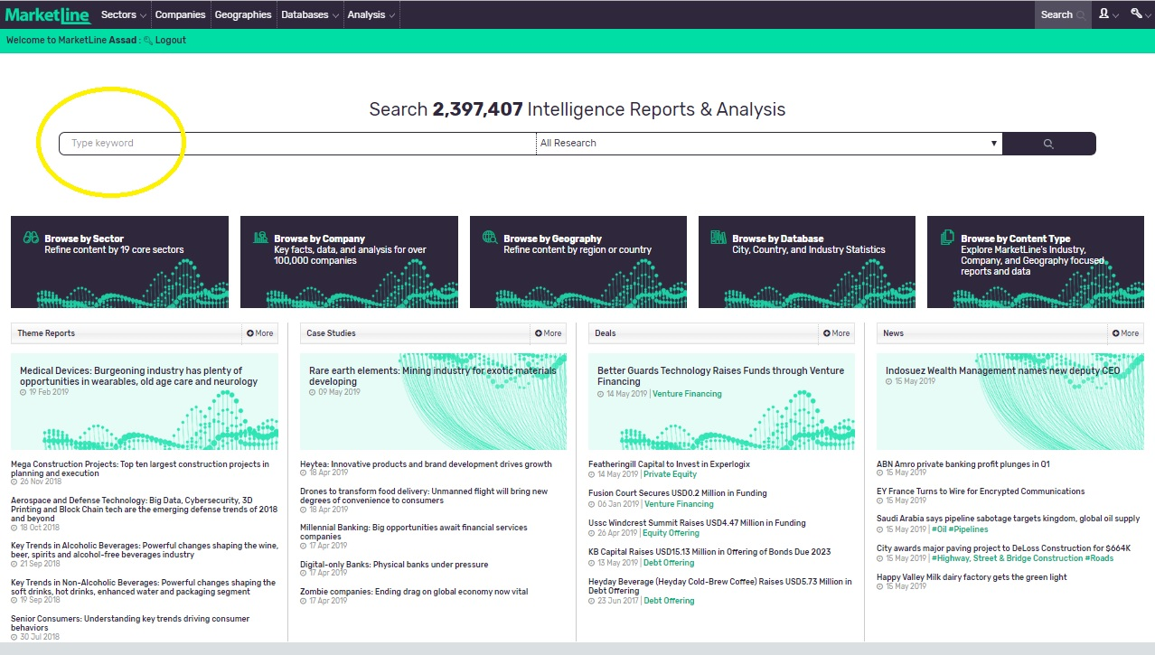

- You will be taken to a results page showing the top results for each of MarketLine’s research types matching your keyword search.
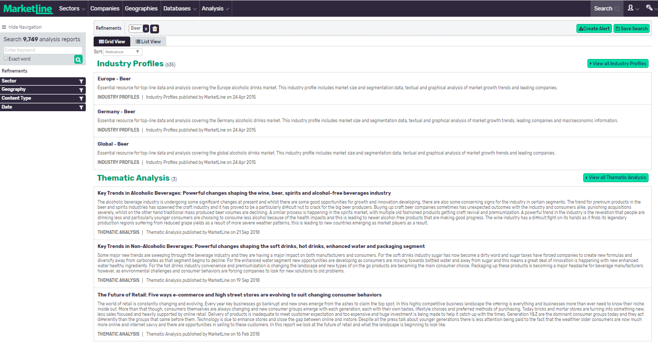
- To see all relevant results by research type, click the relevant “View all Industry Profiles”,” View all Thematic Analysis” etc. buttons on the right hand side of the screen.
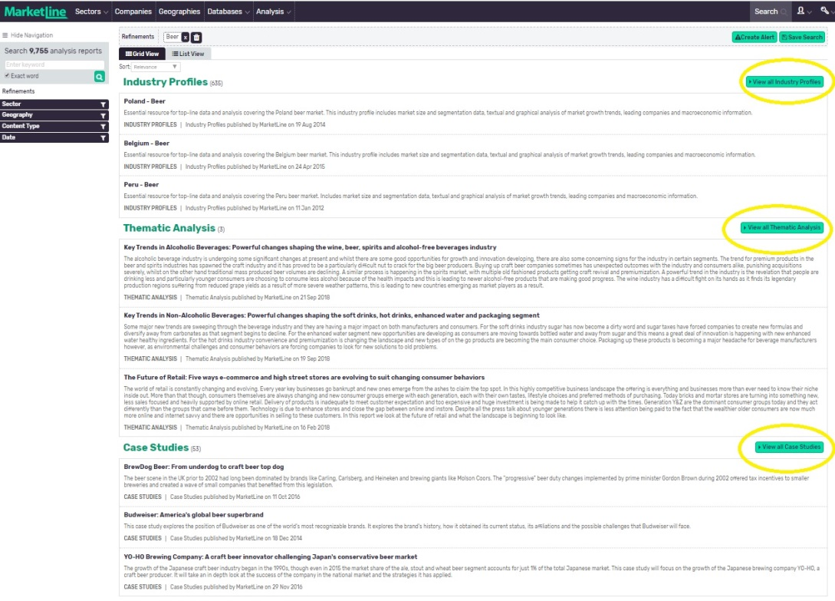
- Search results can be refined with an additional keyword search or by using the Refinements options in the left-hand column of the page. You can narrow by keywords, sector, geography, content type, or publication date.
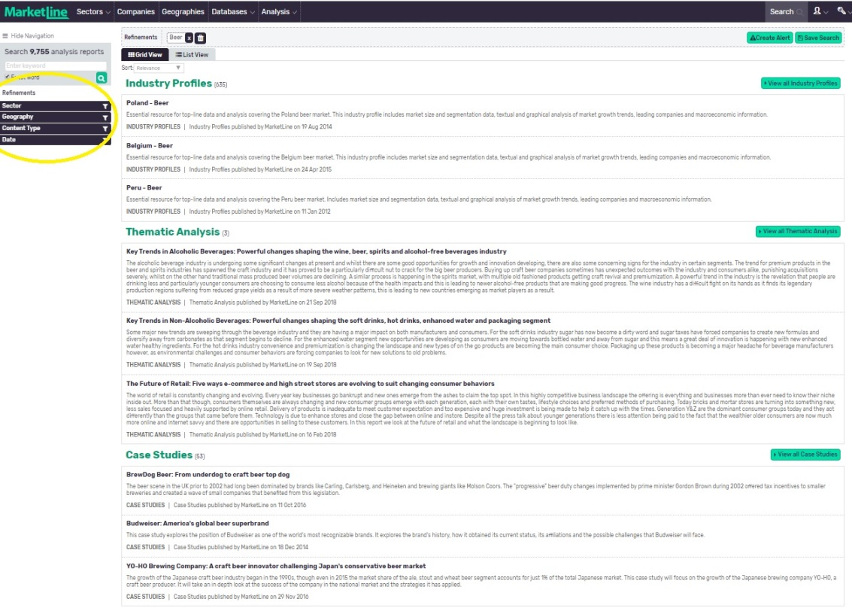
- You also have the option to view your results as a list or in grid view using the relevant tabs at the top of the search results page. ‘List’ will display all results according to the parameters chosen, while grid will arrange your results by information type.
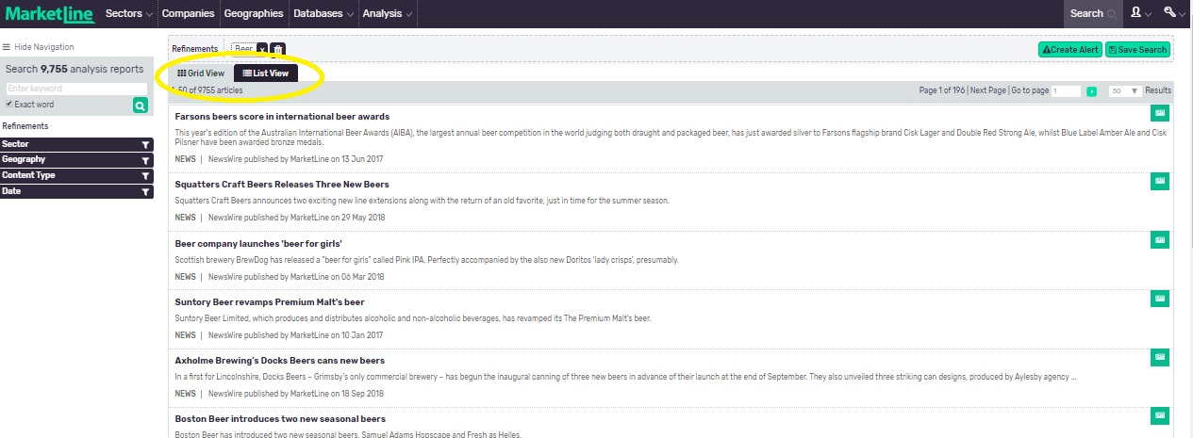

‘Browse By ..‘
- As an alternative to the keyword search, the MarketLine Advantage homepage has options to Browse by Sector, Company, Geography, Database or Content Type.
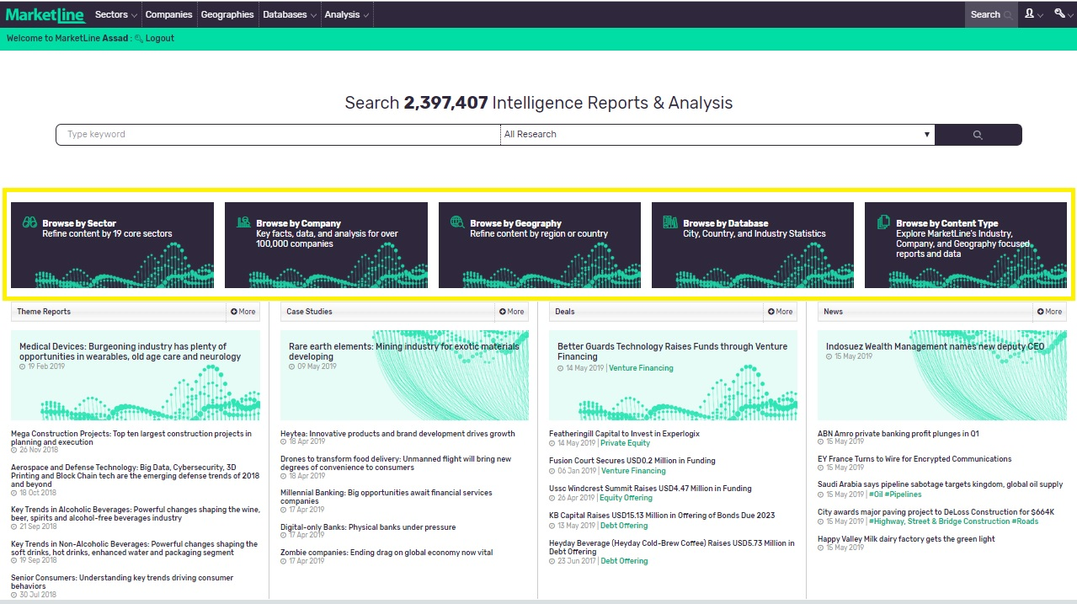

- Browse by Sector allows you to select and display all content available for each of MarketLine’s 19 core industry sectors.
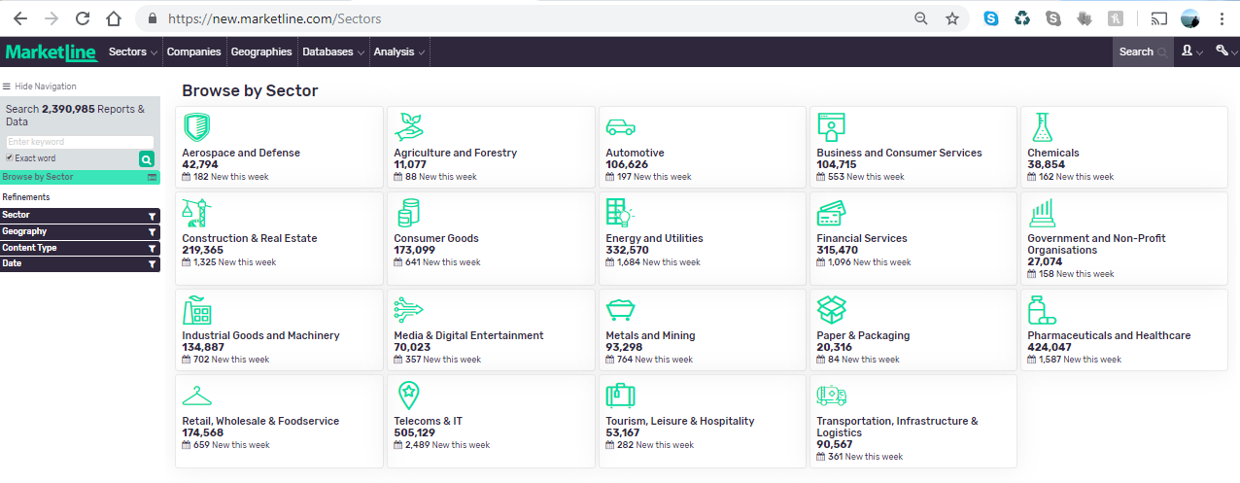

- Browse by Company takes you to our Companies module where you can search or build lists of companies, or access our analyst curated lists of leading companies.
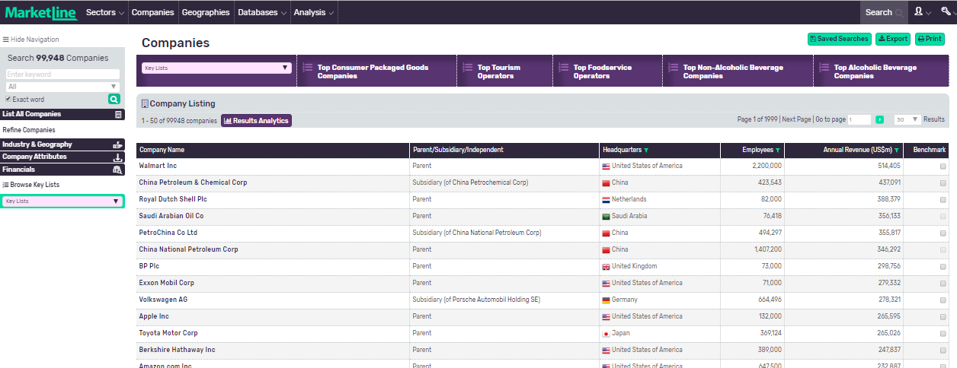

- Browse by Geography allows you to select and display all content available for any major region or country.
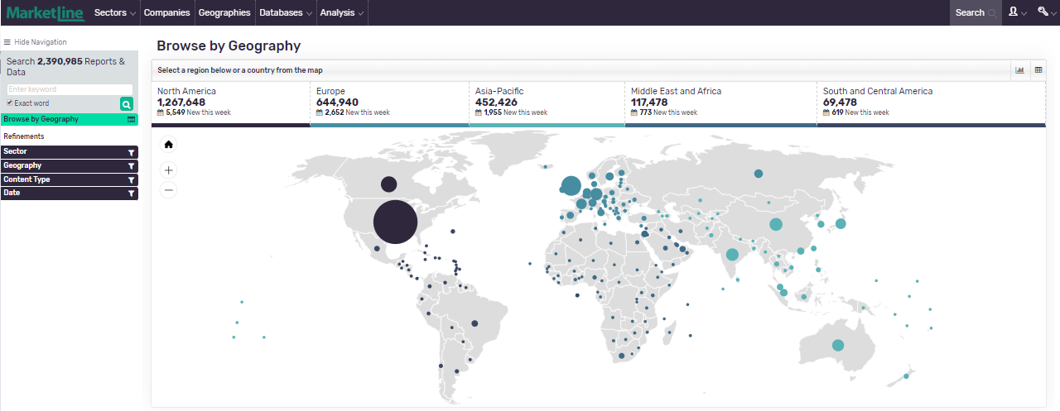

- Browse by Content Type shows and describes the types of content available on MarketLine, and enables you to quickly drill down if you are interested in one particular content type.

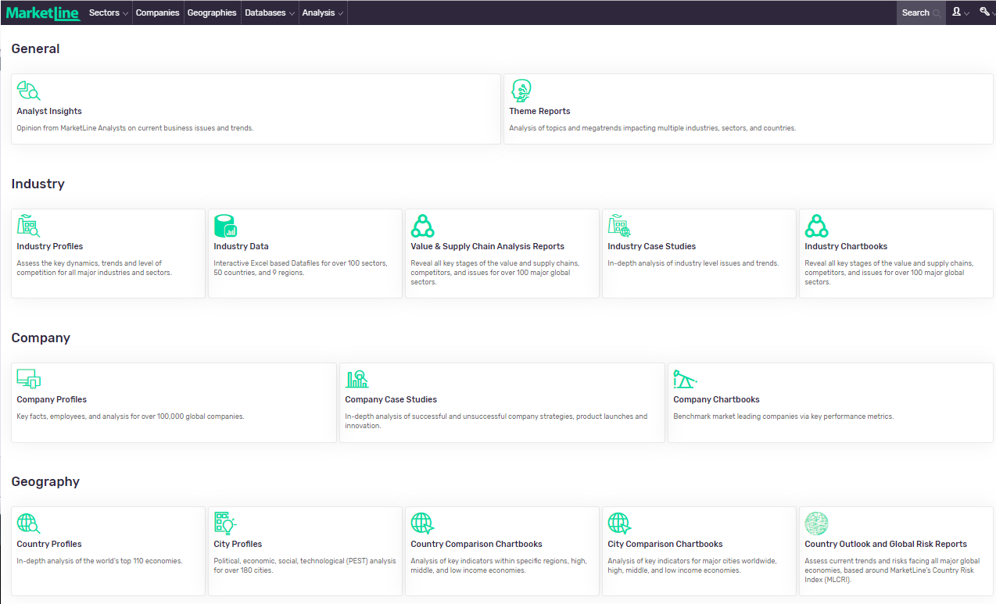

- Browse by Database shows and describes the Databases available as part of your MarketLine subscription.
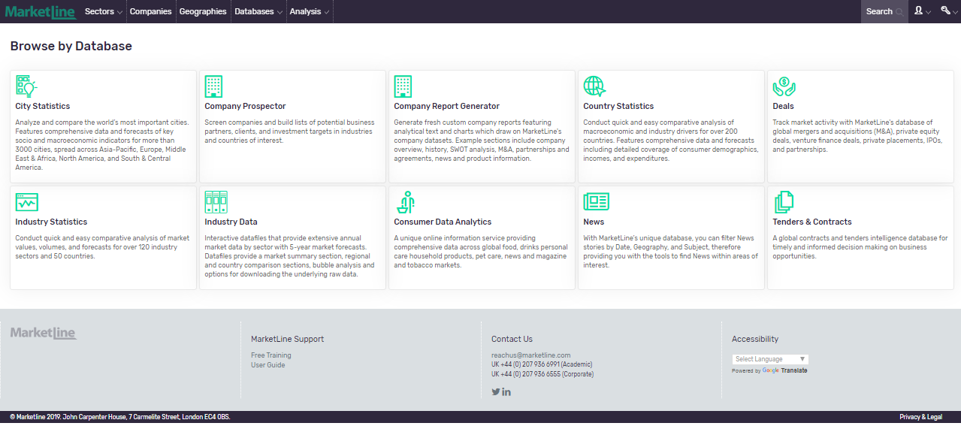

Downloading
- Depending on the information type, MarketLine Advantage allows you to download whole reports or sections of content in PDF, Excel, or PowerPoint formats.
- Where available click the relevant icons select to download or save the file to a location on your computer. For example:
- 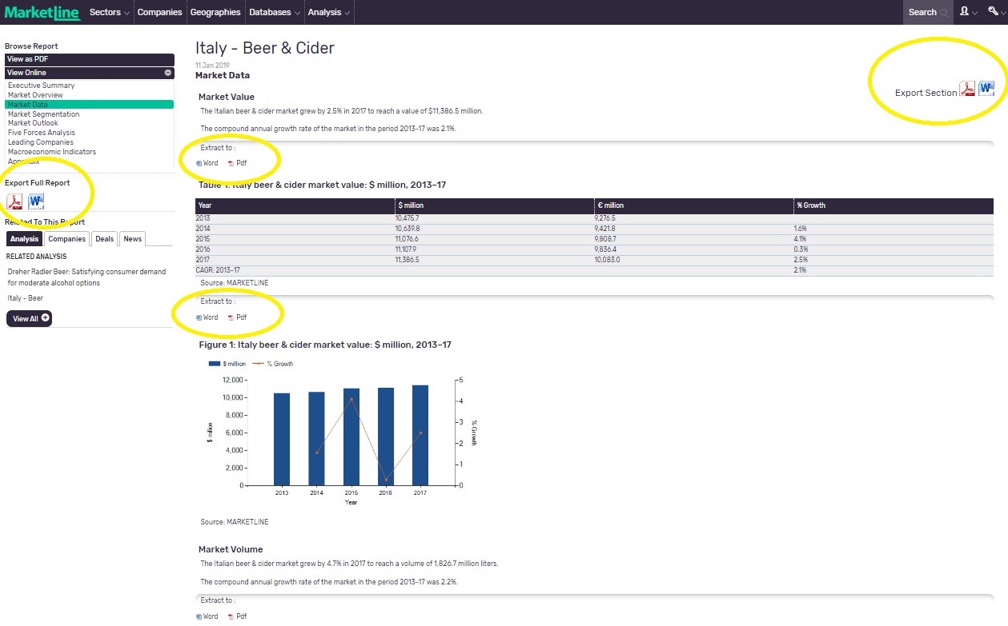

Translations
If you wish to view the MarketLine Advantage platform in another language, you can use the Google Translate. Google’s translation service allows you to translate words, sentences, and web pages between any combination of its 57 supported languages.
For more information and to find out how Google Translate works, please click here.

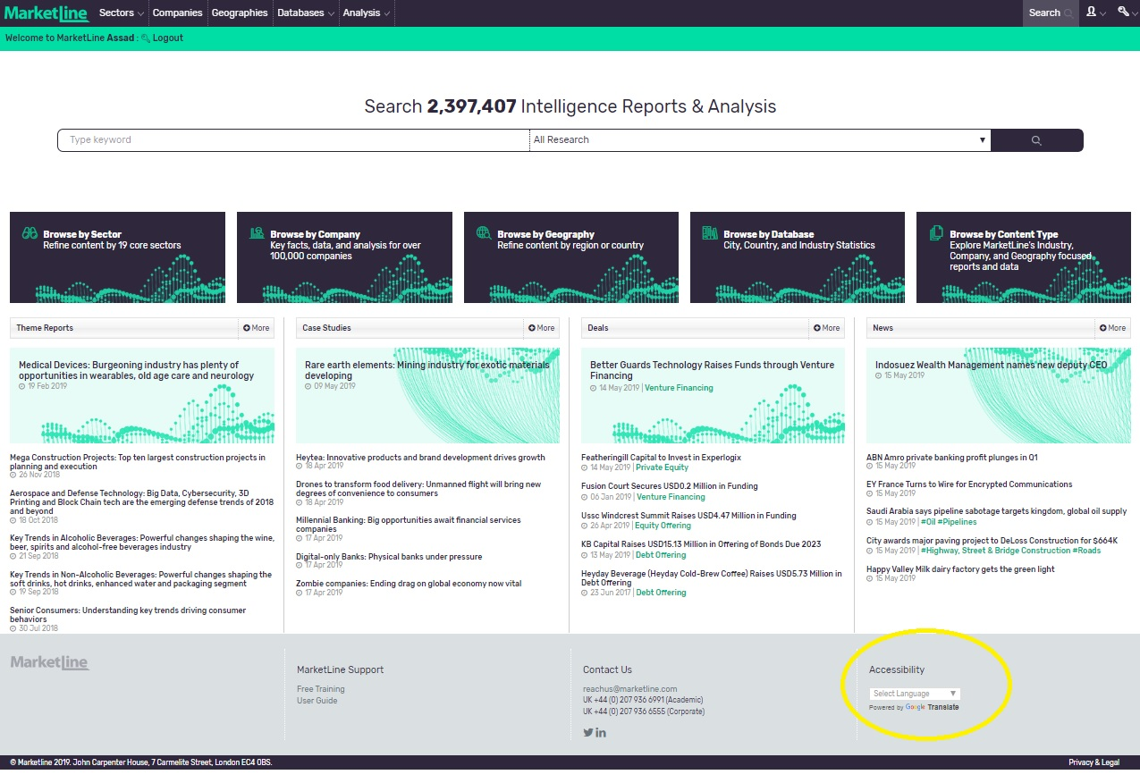

Additional User Guides and Video Tutorials
To access additional User Guides and Video Tutorials for MarketLine’s platform and Databases please click the links below.

Companies, News and Deals
Video Tutorial: https://bcove.video/330HWM5

Search and Browse
Video Tutorial: https://bcove.video/2OeQE61

Country Statistics
User Guide: https://www.marketline.com/wp-content/uploads/MarketLine-Country-Stats-User-Guide-2019.pdf
Video Tutorial: https://bcove.video/2yuEUBK

City Statistics
User Guide: https://www.marketline.com/wp-content/uploads/MarketLine-Cities-User-Guide-2019.pdf
Video Tutorial: https://bcove.video/2KmpG7h
Consumer Data Analytics
User Guide: https://www.marketline.com/wp-content/uploads/MarketLine-Consumer-Data-Analytics-User-Guide.pdf
Video Tutorial: https://bcove.video/2MIIWPc
Industry Statistics
Video Tutorial: https://bcove.video/2YPWZZu

Company Prospector
Video Tutorial: https://bcove.video/2MDXpf0

Influencers
Video Tutorial: https://bcove.video/336f0lx

Case studies
Video Tutorial: https://bcove.video/2Ze4St3

Chartbooks
Video Tutorial: https://bcove.video/2Z90f3h

Industry Data
Video Tutorial: https://bcove.video/2NnbfCQ

Value Chain Analysis
Video Tutorial: https://bcove.video/2NlelaE

Ask an Analyst
MarketLine Analysts are on hand to answer any queries relating to MarketLine content. You can access the Ask an Analyst form by clicking on the Account Tools (head icon next to search box on the top navigation bar), then Ask an Analyst.
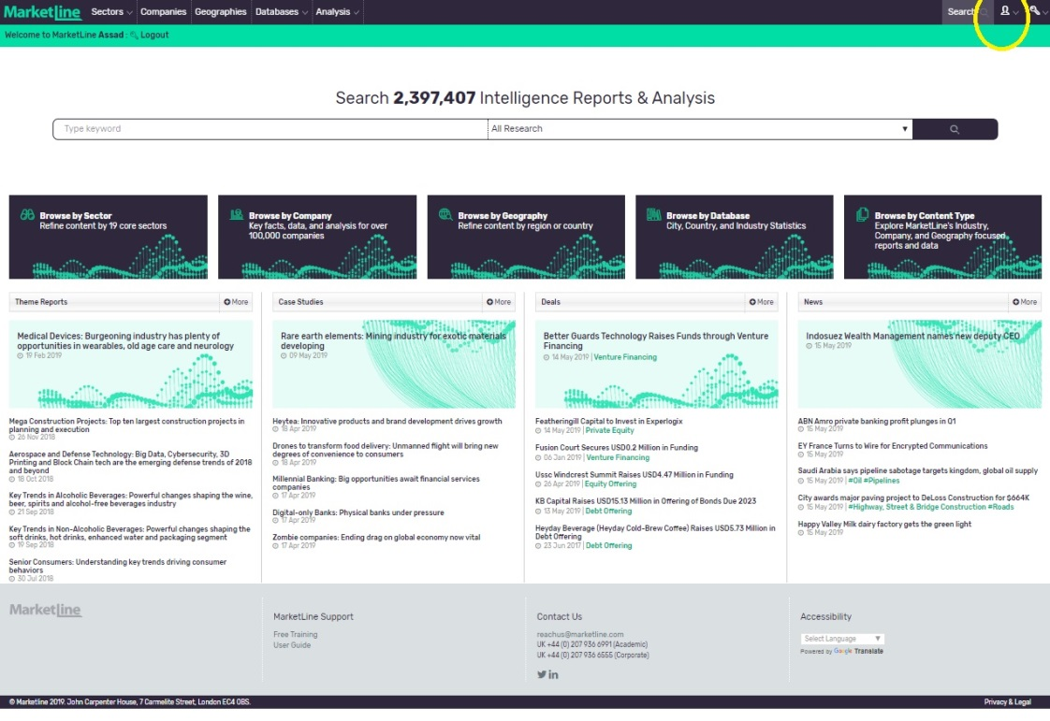

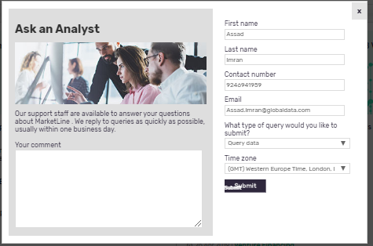

Need further help or training?
You can have your own personal training sessions with our Client Services team. Check out our training calendar or email us on assistme@marketline.com.
Phone:
UK +44 (0) 207 936 6991
US +1 646 625 7389
AP +61 (0)3 8842 2478

